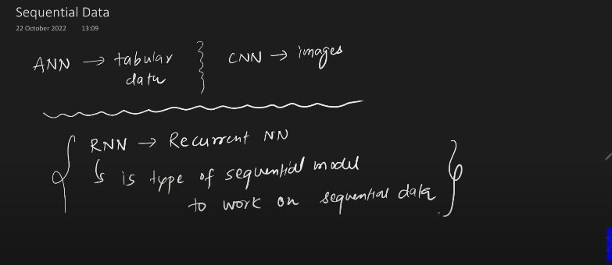
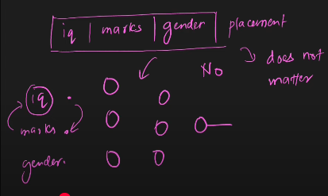
Sequence does not matter. It can be can be iq, marks, gender any permutation(arrangement). Whihc will be fed to the network at once.

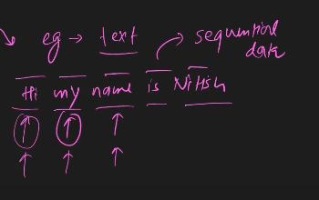
Sequence matters. in RNN.
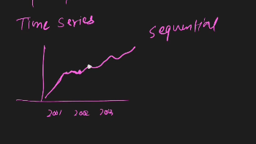
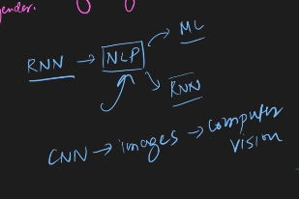
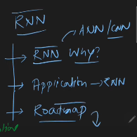
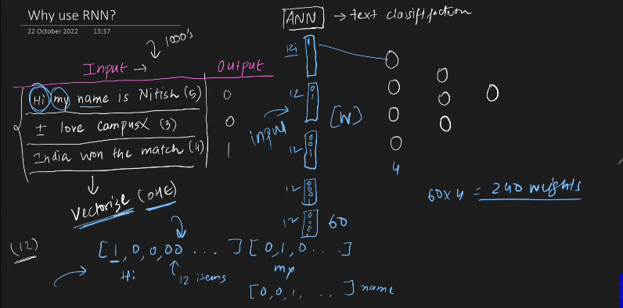
This is the problem with the ANN is the structure is fixed. There are 12 unique words , in the whole corpous.
- For the first sentence we make the 12* 5 number of vectors.
- For the 2nd vector, we make the 12*3 vectors.
- For the 3rd , we make the 12*4 vrctors.

So we make the zero padding to overcome the problem.
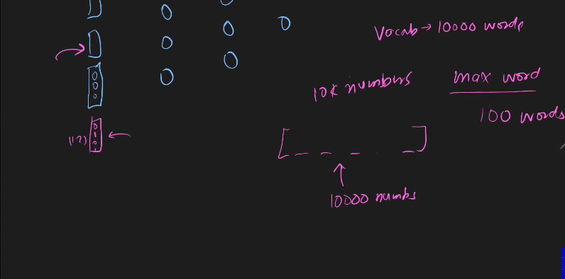
Now consider the corpous has 10k number of unique words in it. When we have a sentence with only the 5 , then we need to insert the 9k 995 zero paddings, irrelevant.

Problem With Text Data to fit for the ANN:
- Text Input(It is varying in size).
- So we do unnecessary computation, while we training the data.
- In test data we have only the 200 unique words, we cannot come to conclusion regarding the number of the paddings to be made. Zero padding fails.

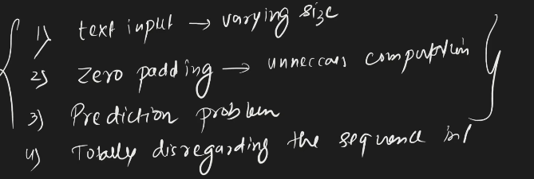
4th - because for the ANN we are passing the whole data at a time, hence the semantic meaning is getting lost. ANN cannot have the memory.

To overcome the problem, we moved on to RNN.

Applications:
- Sentence completion.
- Sentiment analysis.
- Image caption generator.
- Machine Translation(Language converter, google translate).
- Question and Answer Demo.

Why RNNs??
They work on the sequential data properly.
A specially category NN, which has the memory feature. Hence they work great on the sequential data.

When you are inserting the data to RNN, it has to be in (timesteps, input_features).
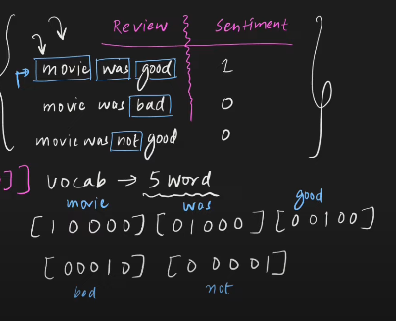
The time what we give must start with 1.Initial T=1, hence it keeps on going.
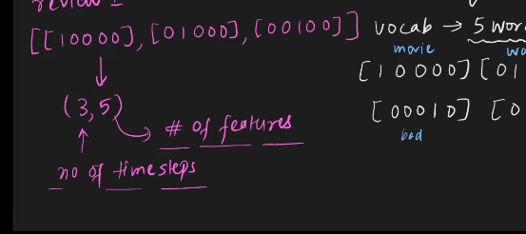
Input to the RNN.
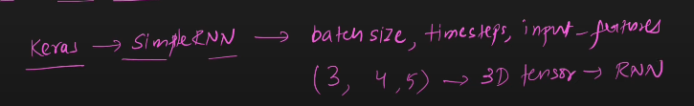
batch-size = 3, because of the number of inputs(reviews)
Timestamp = 4, max(all the time stamps, in each and every input)
Input_features = 5, number of features produced because of unique keywords found in corpous.

So when ipnuting to RNN using the Keras: (number_of_input or batch_size, TImestamp- representing maximum number of unique words available in the text in any one of the input texts, Number of features.)

Creating Input Ready.
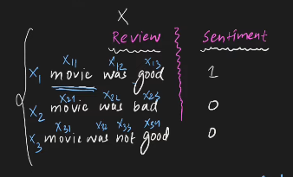

Difference between the ANN and RNN:

- Input
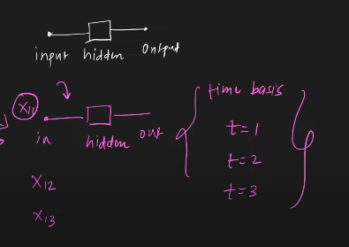
In ANN, we make the input all at once, but in RNN, input is given one by one.

- Architecture
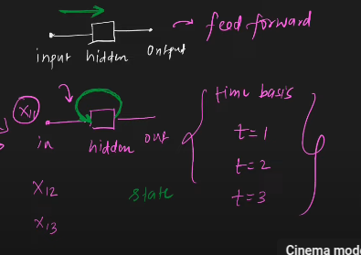
  - ANN works only on the feed forward architecture. But the RNN has seperate struture, That loop, which made RNN RNN.
  - Proper Architecture
    - 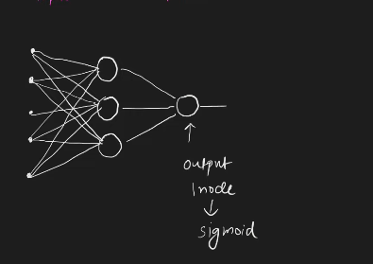
    - This is simliar to the ANN. But we need to make RNN out of it.
    - This what makes RNN
    - 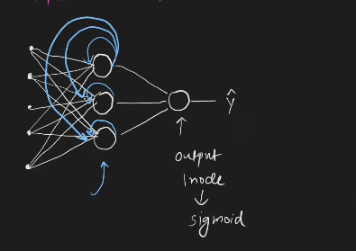
    - For the rest of the nuerons, it will be connected in the same fashion.
    - 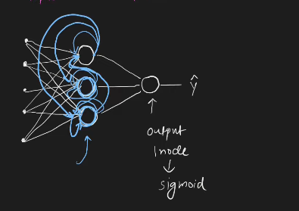
    - The messy architecture.
    - 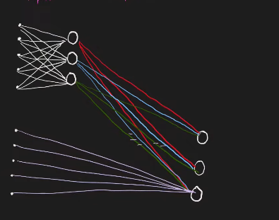
    - This is the original and real.
    - At t=1, When the x11 is given as the input this what happens(below)
    - 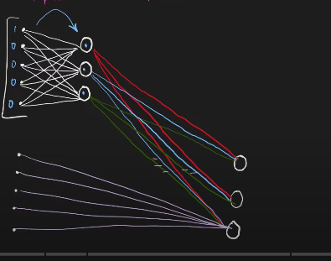
    - 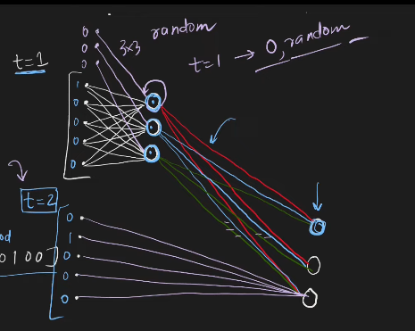
    - Parameters of the RNN
    - 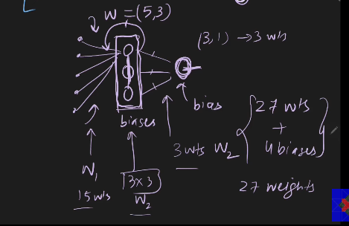
    - model= sequential()
    - model.add(SimpleRNN(3, input_shape=(4,5)))
    - model.add(Dense(1, activatio=’sigmoid’))
    - model.summary()
    - model.get_weights()[index] - is used for getting the weights of the model.

  - Forward propagation in RNN
    - Unfolding through time = Loop in RNN.
    - 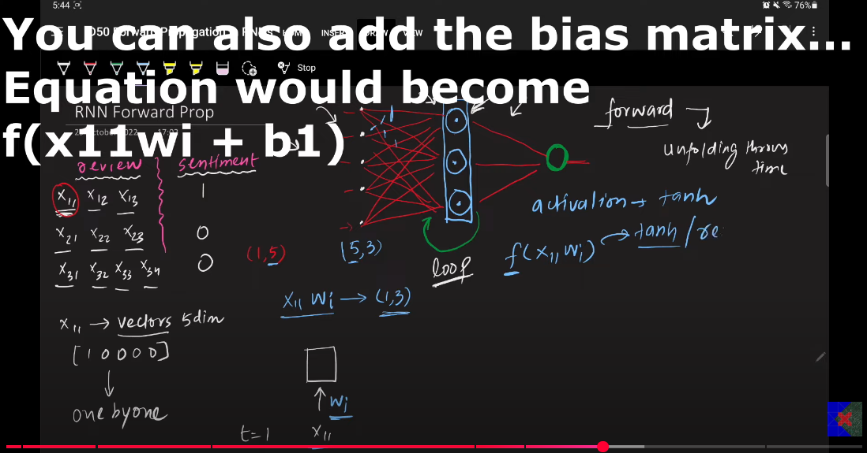
    - default activation function: For every nuerons is tanh. If you do not mention regarding this , it will be set automatically.
  - Main equation: f(x11*w1+bi):
    - x11 - input(1*5), a single word in the sentence.
    - w1 - (5*3), can obtain this =using the model.get_weight()[0] .
    - bias(1,3)
  - 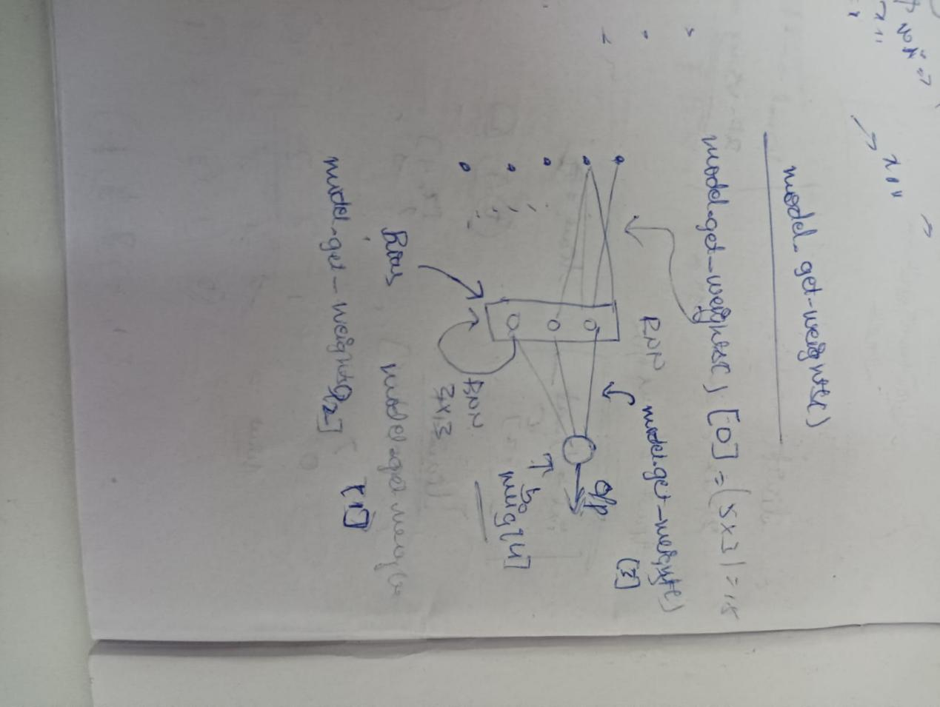
  - 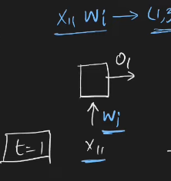
t=2
  - 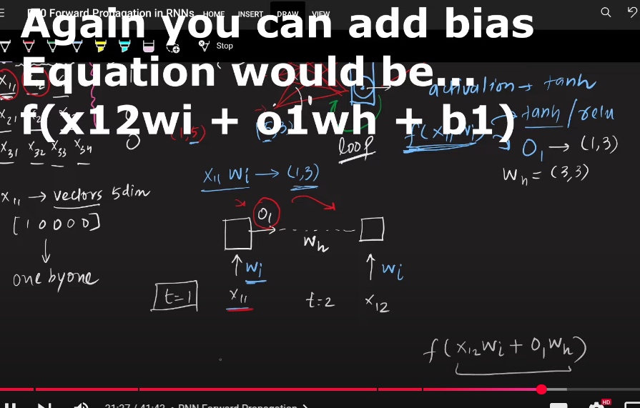
  - t=2
  - 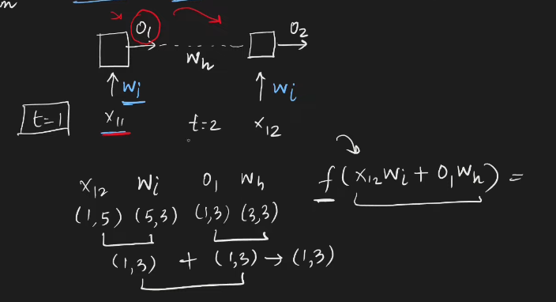
  - 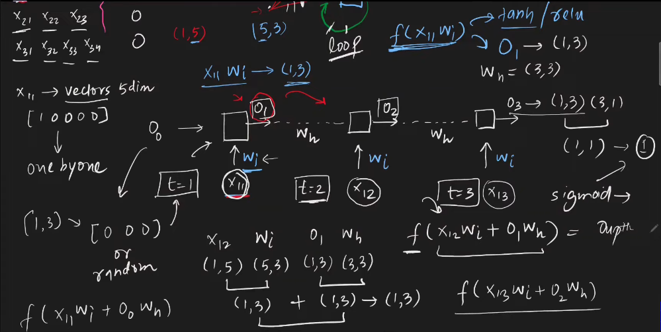
  - Reccurent- Because the hidden layer is occuring again and again to get the output, that is why it is called as RNN, even thouhg we are using the different inputs x11, x12, we are using the same weights/ parameter sharing or weight sharing is used again and again.
  - A simple RNN can process 10 time steps, taht is used as memory.
  - 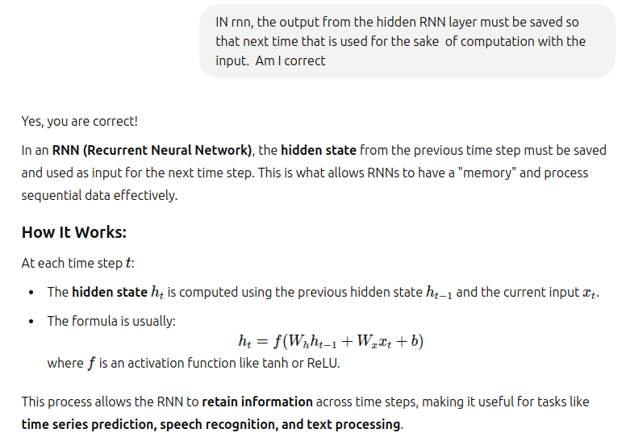
  - 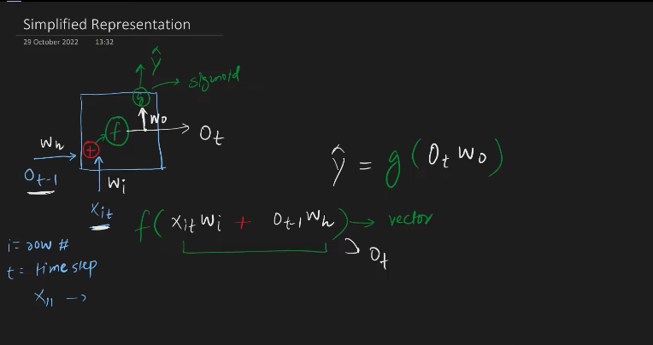

- Text processing
  - 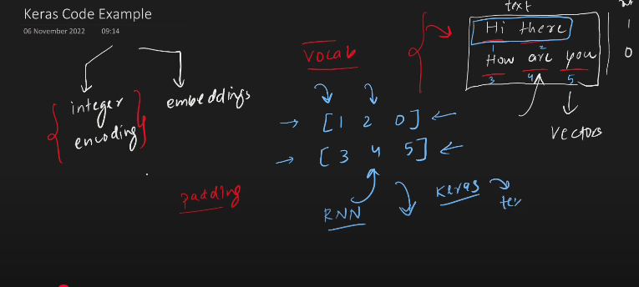
    - Integer encoding - Unique words will be given the unique numbers, then zero padding.
  - 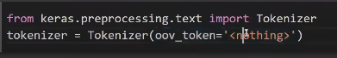
    - oov token(out of vocabulary) - At the time of testing when you some word which is out of the token that will be replaced with the oov token.
    - keras.preprocessing.text
      - text_to_word_sequence(text) - Returns sentence to array of words []
      - tokenizer = Tokenizer(num_words = 10) - keeps only top 10 words.

    - Steps involved:
      - Take the input from the user, or from the paragraph.
      - In keras.preprocesing.text , import Tokenizer
      - In Tokenizer we fit the oov_token(Out of vocabulary), so when something irrelevant came, we will keethis word instaed of this while testing.
      - Tokenizer converts series of text to words, this involves many things, converting from Upper case letter to lower case letters.
      - This is used to convert words into series of tokens. t
      - Then use the text_to_sequence- this is used to convert the sentence to the lits which has number in it representing the words and its sequence of numbers.
      - pad_sequences, this is used for converting into sequences with the padding equals to post.
        - 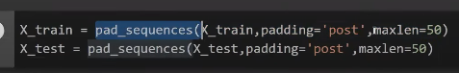
        - max len = takes only first 50 words in a sentence for processing, rest everything is ignored.
        - 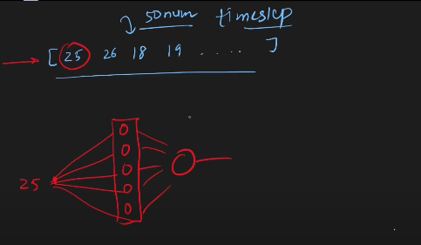
        - 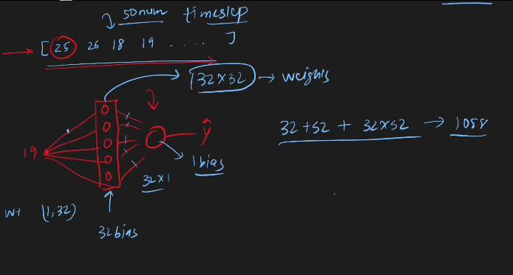
        - 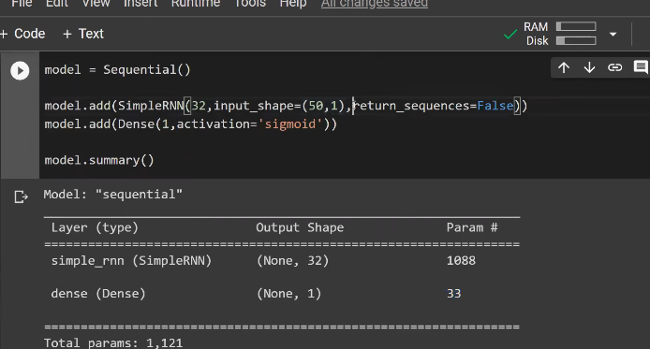
        - return_sequences - if this is made true then it is used to get the output from every hidden layer.
        - This is useful when we have got the sequences like:
          - Named entity recognition.
          - Language translation, need to convert every word into respective language needed.
          - Machine translation.
      - Steps:
        - Prepare the data
        - Create the model sequential.
        - Add RNN layers and customizable architecture.
        - Model compile.
        - fit, Then epoch data thorugh the model.

- WORD EMBEDINGS:
  - Given a series of text, we need to convert that into the vectors. The vectors we create must capture the semantics of the word.
  - In Keras we can make it word embedings.
  - Embedings layer in Keras:
    - 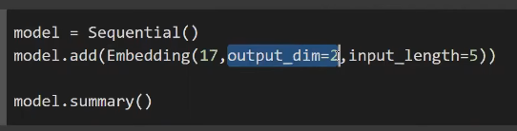
    - 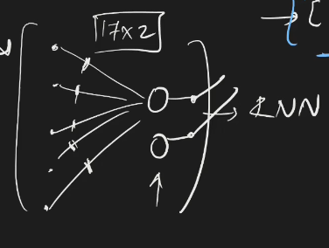
    - 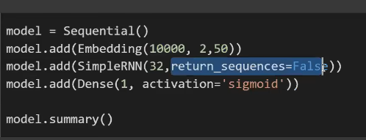
    - 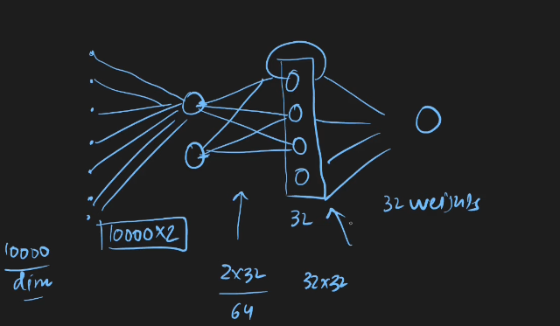
    - It is always better to use the embedings with our custom data.
    - Then use it for the sake of generation of the output.
    - 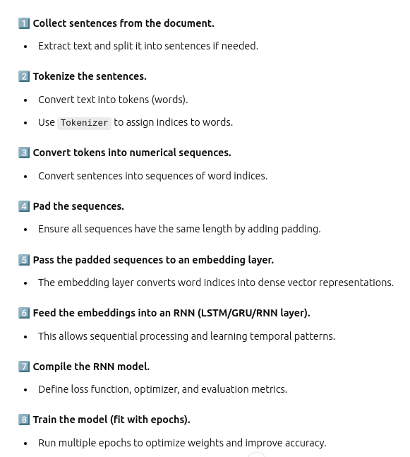
- Types of RNN
  - Many to one RNN
    - 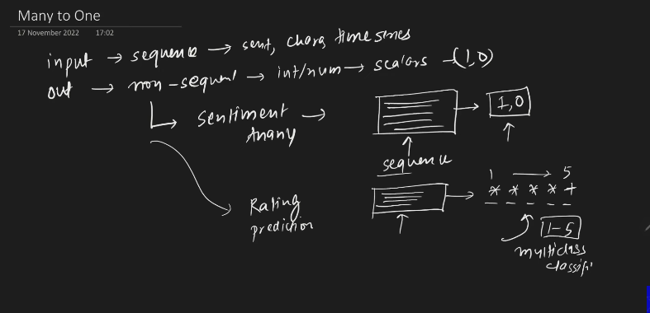
    - 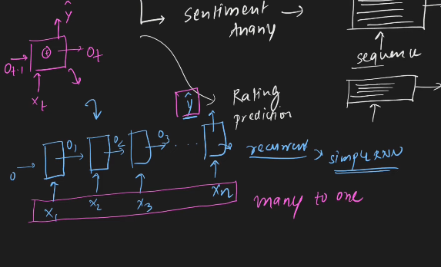
    - Summary: You give the input in sequence to the nueral network, you get a single output.
  - One to Many
    - Input is just the image and we will get the captioning out of it.
    - 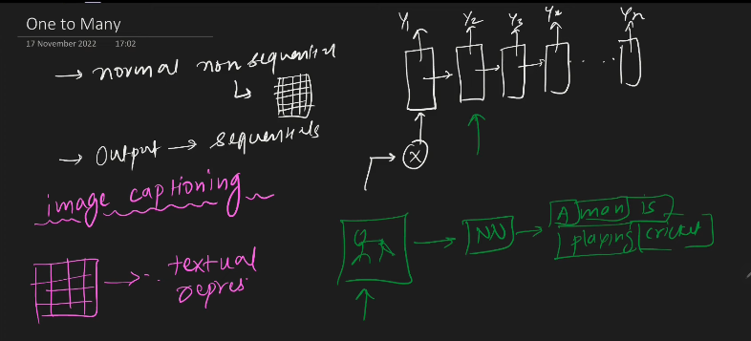
    - Music generation: Give the input to the RNN, like the singer name, you will get the output from the RNN regarding music in terms of the output.
  - Many to Many
    - 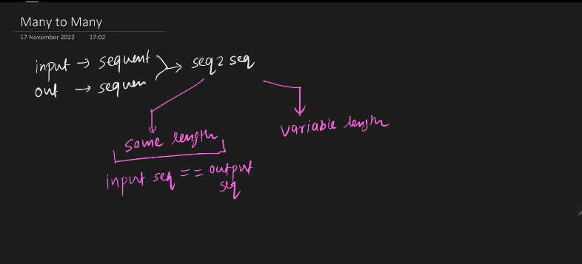
    - 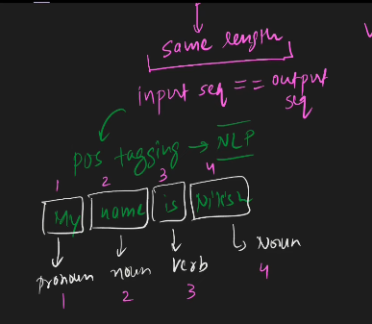
    - 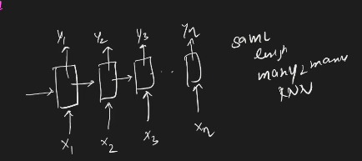
    - Variable Length , input sequence length is not equal to output length sequence.
    - 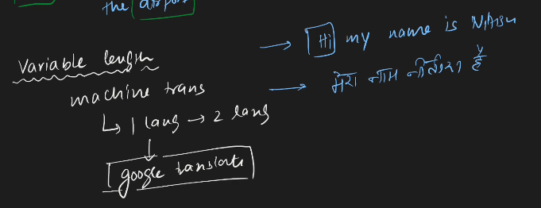
    - 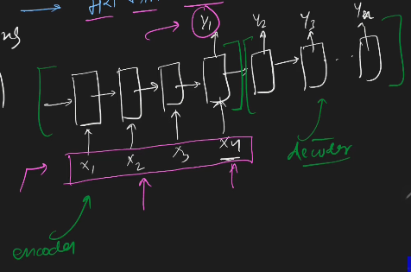
    - Once after capturing the whole contexts this will start to generate the texts, so this has to capture the semantic meaning of it.
    - Encoder - gives the input to the RNN.
    - Decoder - it gives the output from RNN.
    - One to one(Image classification) - ANN OR ANN
    - 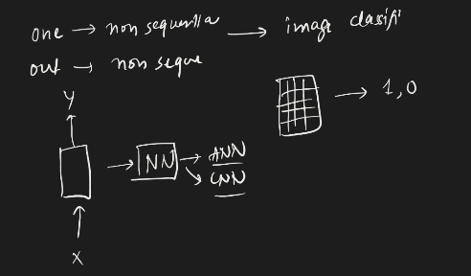

- BACK-PROPAGATION IN RNN
  - 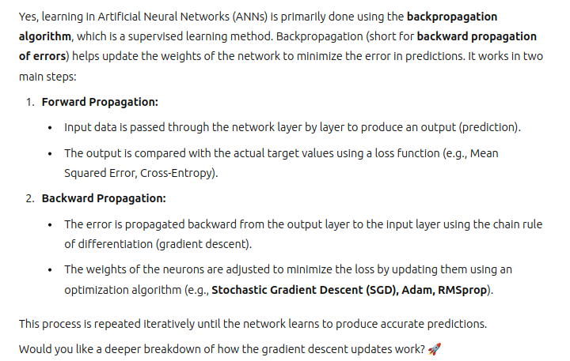
  - Mathematics behind the RNN backpropagation
  - 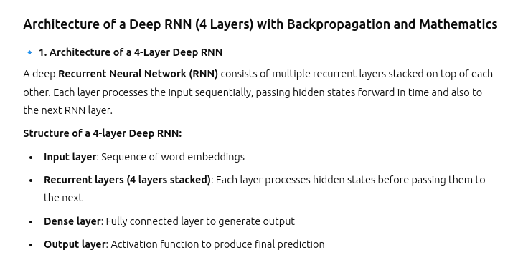
  - 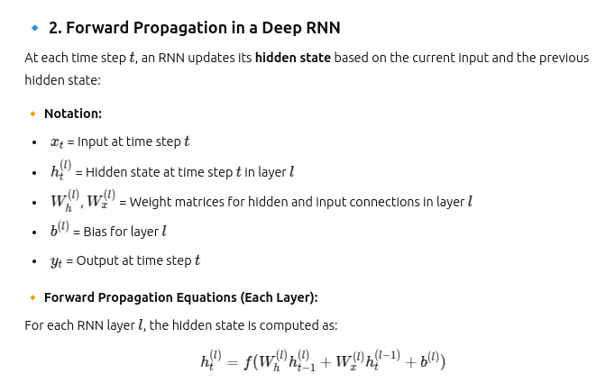
  - 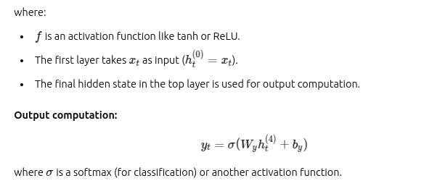
  - 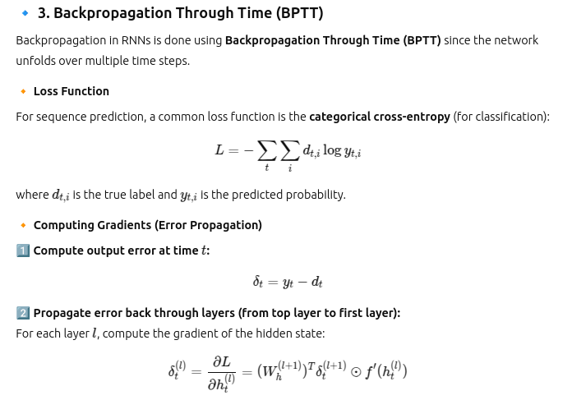
  - 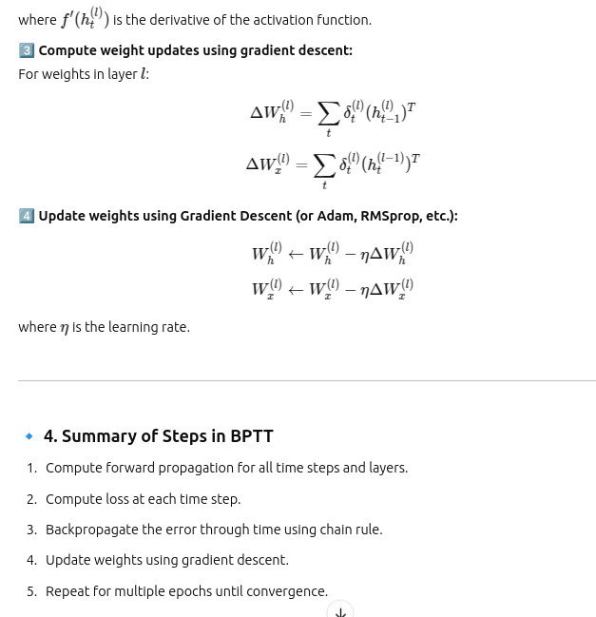
- Backpropagation through time in RNN
  - Many to one sentiment analysis:
    - 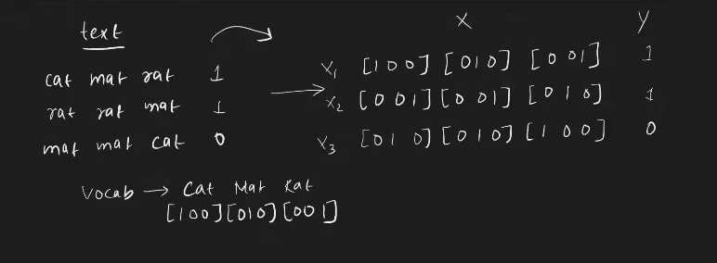
      - Input
    - Architecture
      - 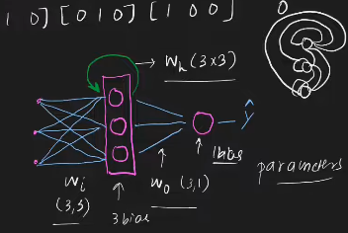
    - Forward propagation:
      - 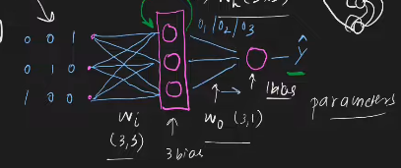
      - 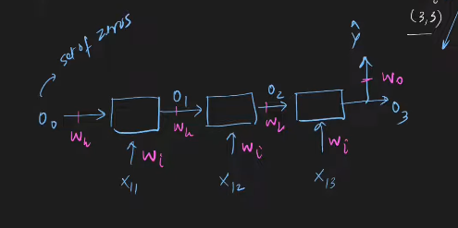
      - 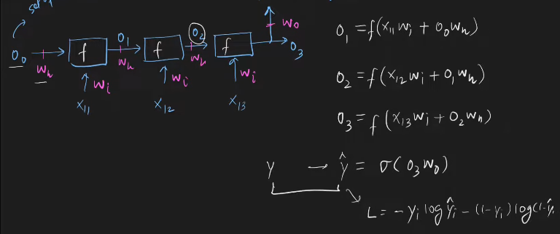
    - Back propogation
      - 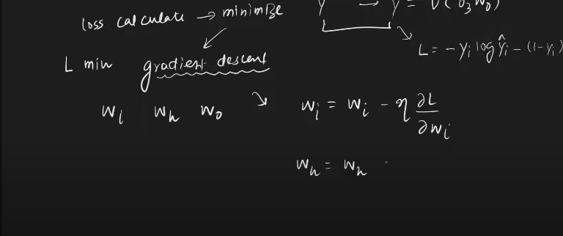
      - 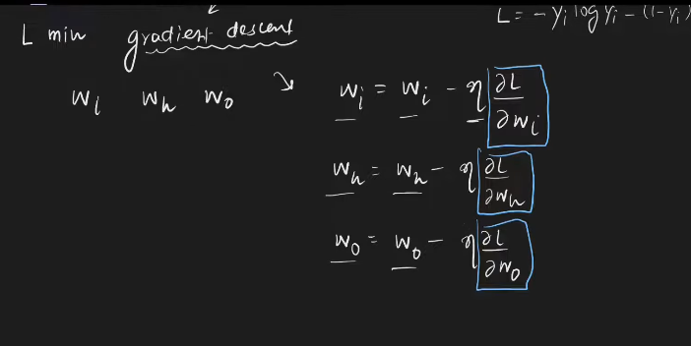
      - 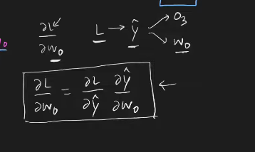
      - Focus on colors vanishing
      - 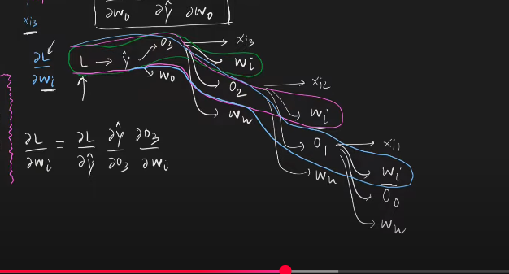
      - 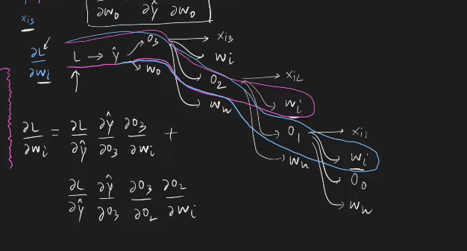
      - 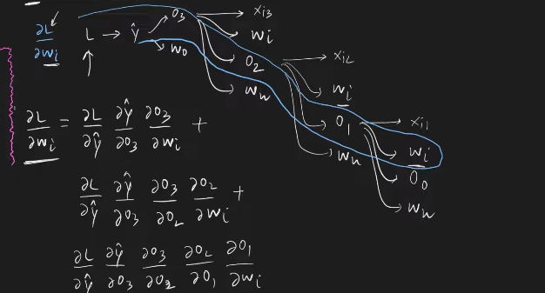
      - You learn this back propagation after Thursday after completing the class work and meetings.

- Problems with RNN
  - 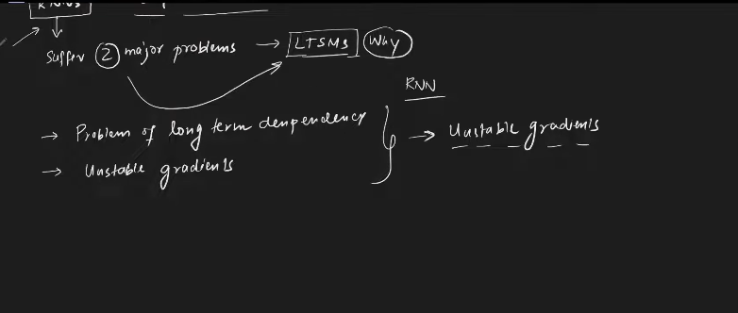
    - 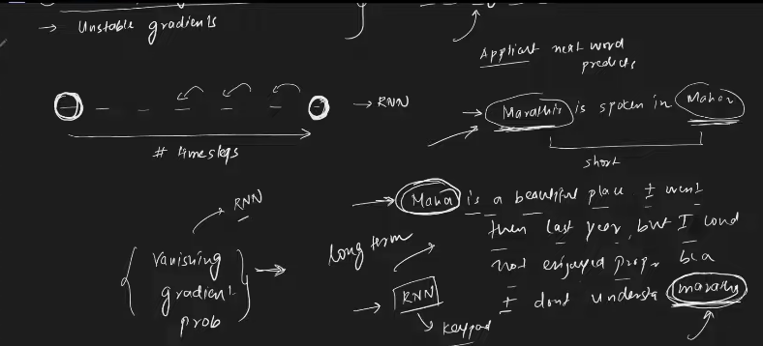
    - Vanishing gradient and as well as the exploding gardient, these problems are being faced here.
    - This backpropagation algorithm I’ll be soon after completing the wednesday’s work.

LSTM’s

- Difference between LSTM and RNN
  - LSTM maintains 2 states Long term state and short term state.
  - Architecture inside the LSTM, which makes the communication between LTM(Long Term Memory) and STM(Short Term Memory).

- Story behind LSTM
  - Shivaji
    - Whenever there is question regrding who is he?
    - The Architectre should answer that he is a king.
    - So the When teher is input to the short term memory regarding the RAGHAVENDRA SWAMY, this is not going to give any answer. Because it is now filled with SHivaji in LONG TERM.
    - This is the communication between long term and short term .

  - Raghavendra Swamy is Idol, He is the king of Kings.
    - The long term context is now changed to Raghavendra swamy from Shivaji.
    - From now onwards any question that is asked, it has to give the response according to RAGHAVENDRA SWAMY.
    - RAGHAVENDRA SWAMY IS KEPT IN LONG TERM memory.
    - Along with that the short term memory will be working regading LORD Raghavendra Swamy.
    - This is how the communication occurs between Long term memory and short term memory.
- Architecture:
  - 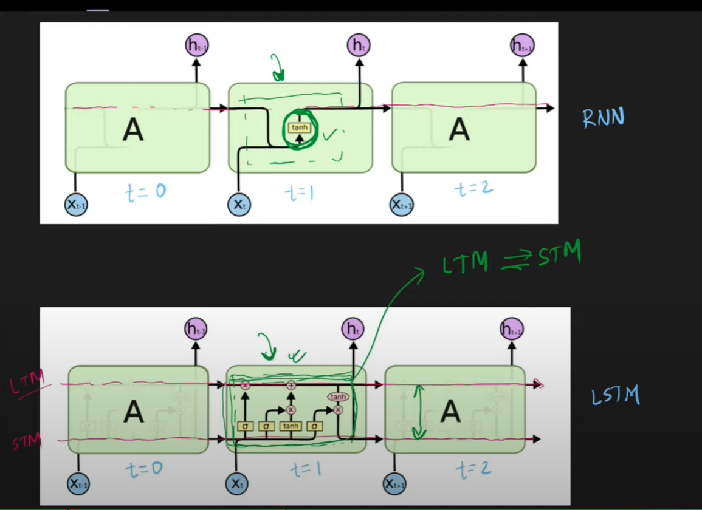
  - The architecture within the Cell is used for communication between Long term and short term memory.
  - 3 gates in LSTM
    - 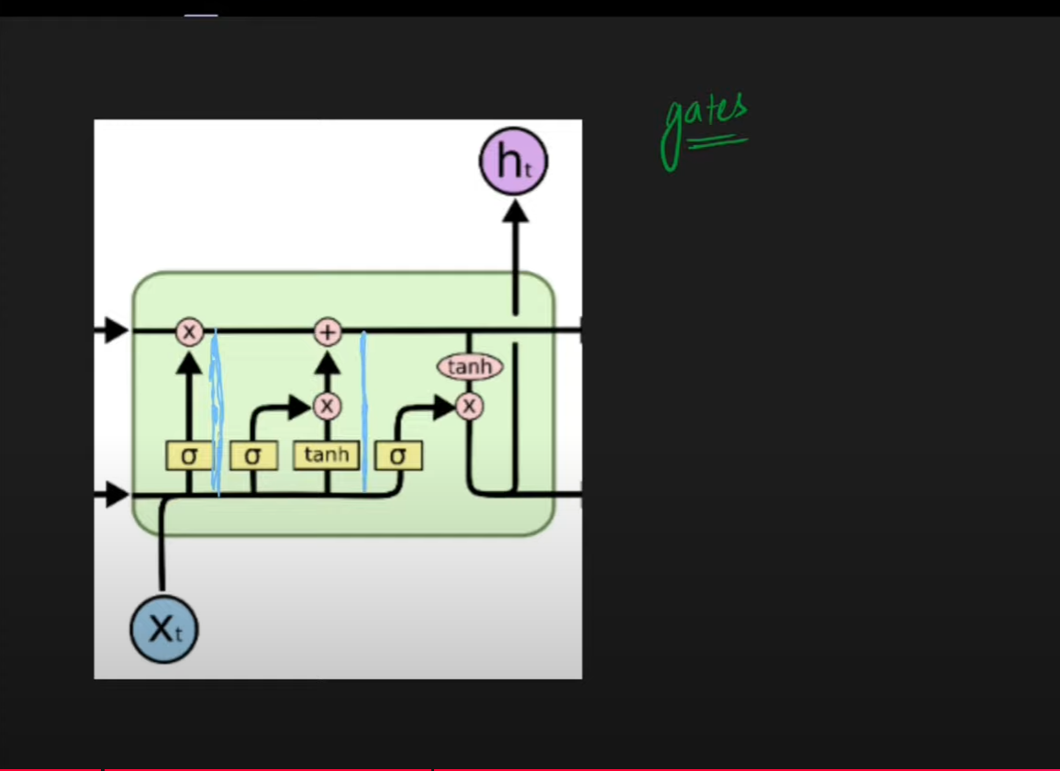
    - 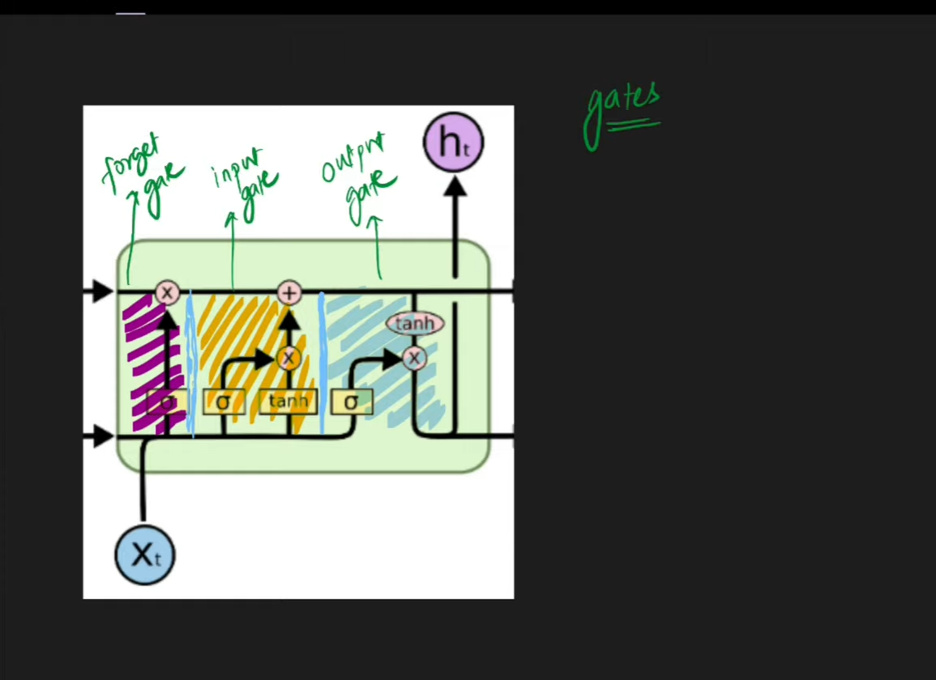
    - Forget gate: Based on the current input and based on the short term memory, this will decide what to remove from the long term memory.
    - Input gate: Based on the input, this will decide what to keep as input in Long term memory. When Raghavendra Swamy’s data is given as input to the LSTM, it has to remove Shivaji from LTM and keep Raghvendra swamy as new input.
    - Output gate: Suppose some question is asked at this moment, so this is used to get the input from the Long term memory and as well as short term memory, then produces the output. This also creates the short term memory.

  - Long term memory is also called as cell state.
  - 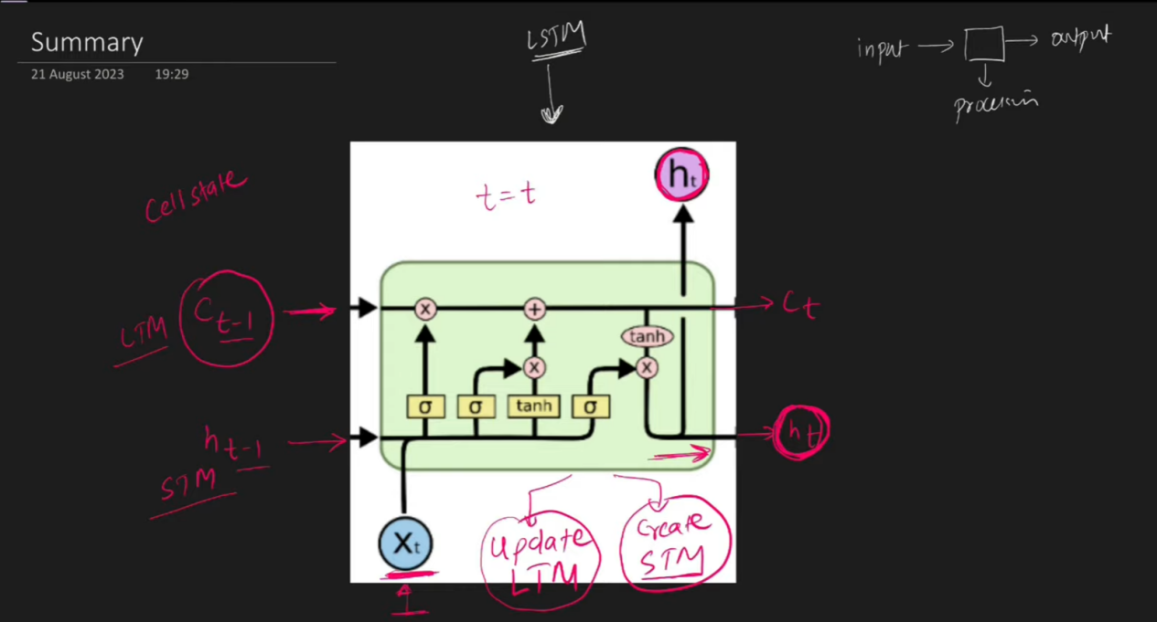
  - LSTM takes 3 different inputs and ht,ct, xti, updates the Long term memory and create the short term memory.

- Internal Architeture with Mathematics behind it.
  - The architecture inside the LSTM is used for communication between the Long term memory an short term memory.
  - previous cell state- Long term . Hidden state(RNN) - short term.
  - Processing wihin the
  - Overvivew of LSTM:
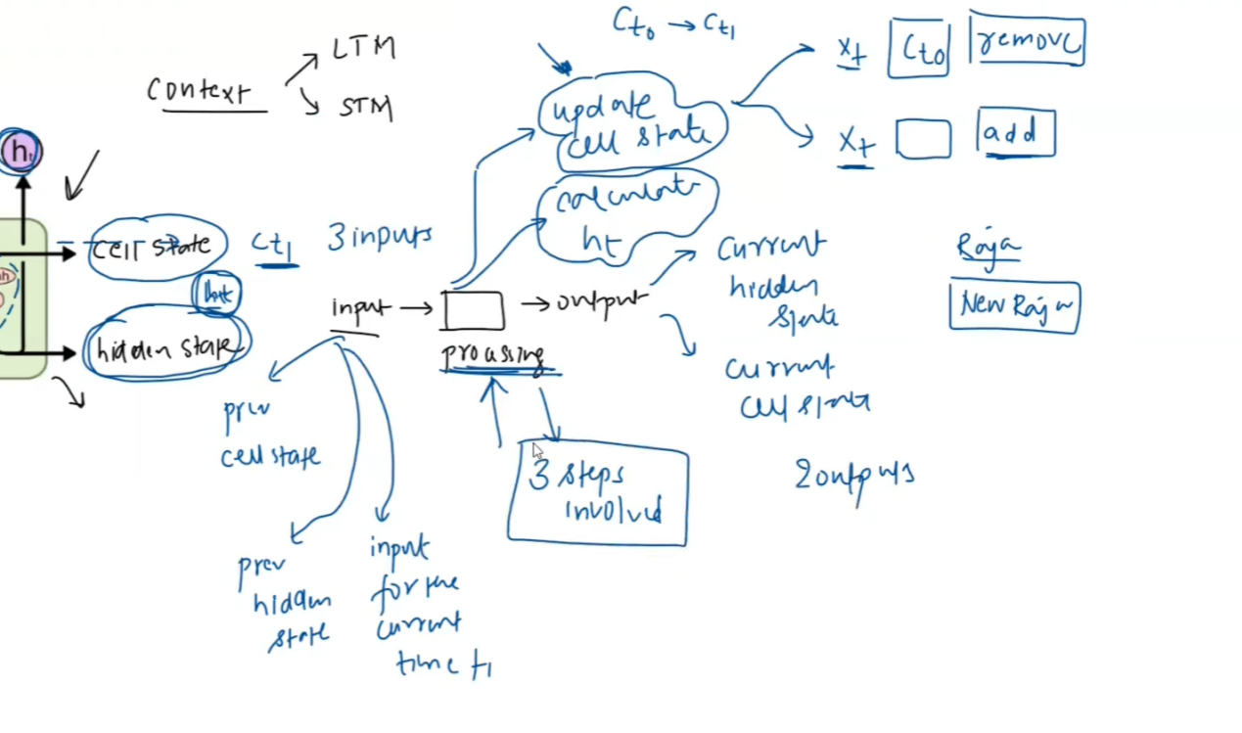
  - In this thing we have 2 different inputs:
    - Previous Cell state( Long Term) from previous state.
    - Previous Hidden state(Short term) Previous state.
    - Current input ,Ex x11.

  - Outputs:
    - Current hidden state(Short term memory)
    - Cell state( Long term memory )
  - Processing inside
    - Based on the current input, remove from the memory.
    - If anything new is found insert into the long term memory.
Both the above is used to update the LOng term memory.

    - Update the short term memory.

- GATES LSTM
  - 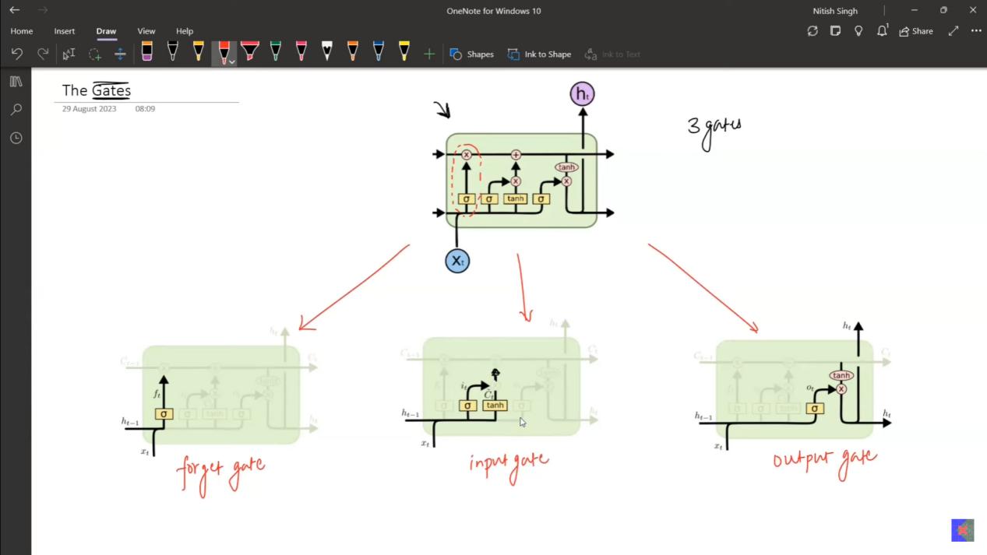
  - 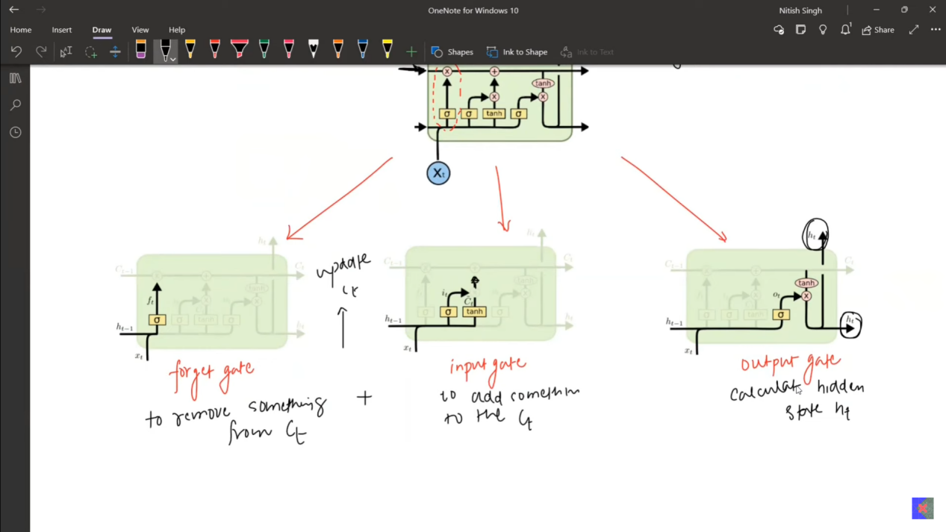
  - 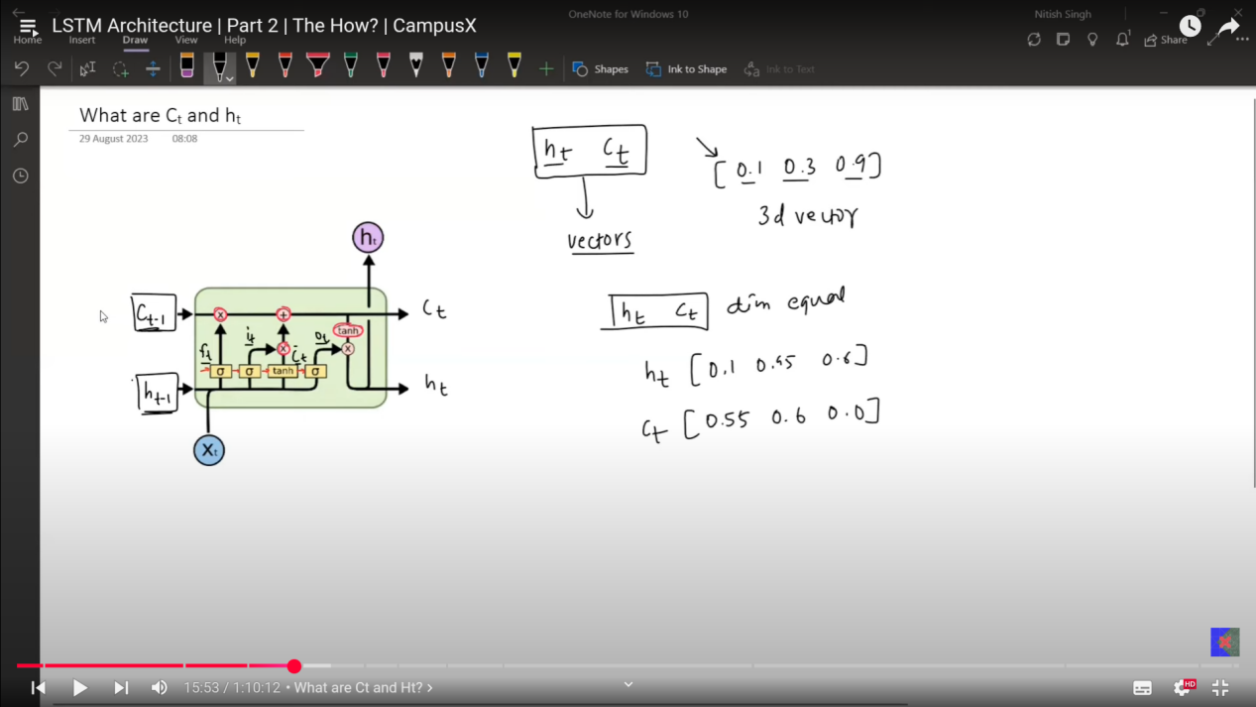
All the symbols that you are watching are the vectors.

Rule 1:
ht and ct are the vectors which are having the same in dimensions.

xt - Converting from text to numbers - One hot encoding.
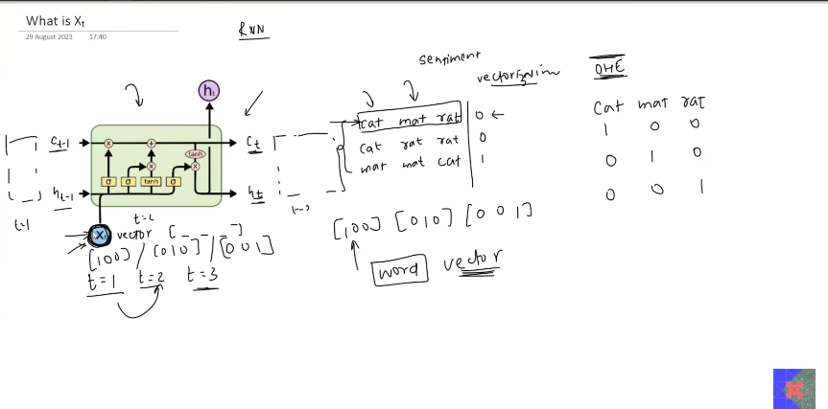
RULE 2:
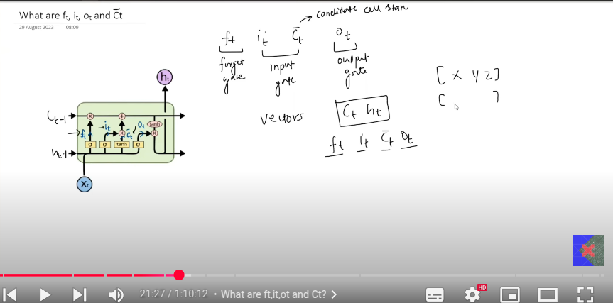
The values of ft, it, ct bar, ot all are of the same dimension. Similiar to the dimension of the ct and ht.

  - 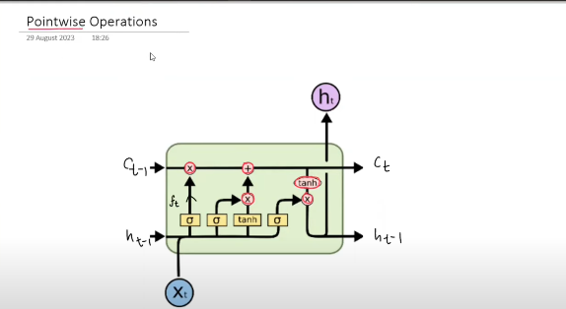
  - The one which are in red is used for making the vector point operartions, which is just the matric multiplication.
  - 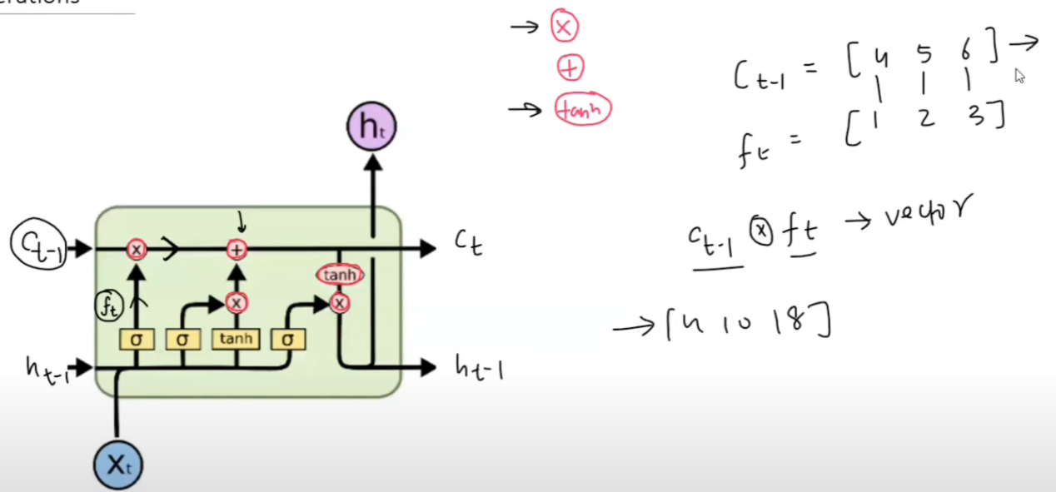
    - Pointwise addition - Ths is used for sake addng the numbers together. Matrix addition.
  - 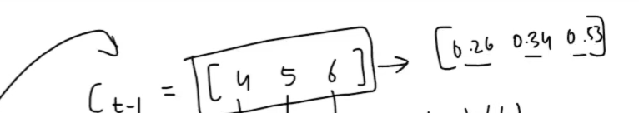
    - This is pointwise tanh.

Now it is time for Yellow color boxes, which are nothing but the nueral networks layers.
The red points are the point wise multiplication.
  - Yellow Box:
    - These are all the NN. The one mentioned in sigma has the sigma activation function in the Nueron of the whole layer. The hidden layer has many nuerons in it. tanh has tanh as the activation function.
    - Hyper parameter-
      - The number of nuerons within a layer is hyperparameter.
      - All the hidden layers must have the same number of nuerons in it.
  - 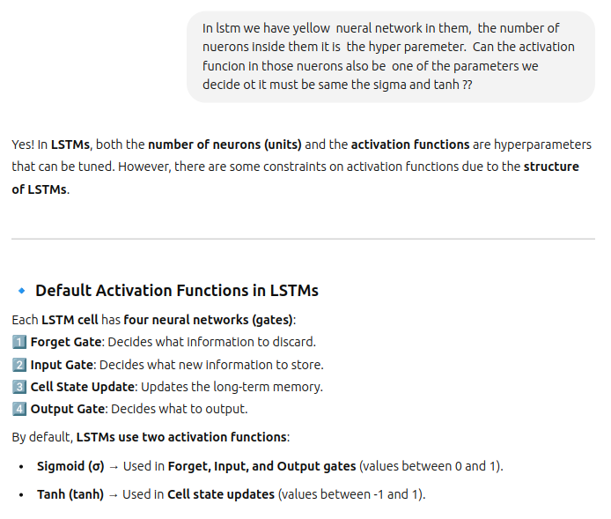
  - 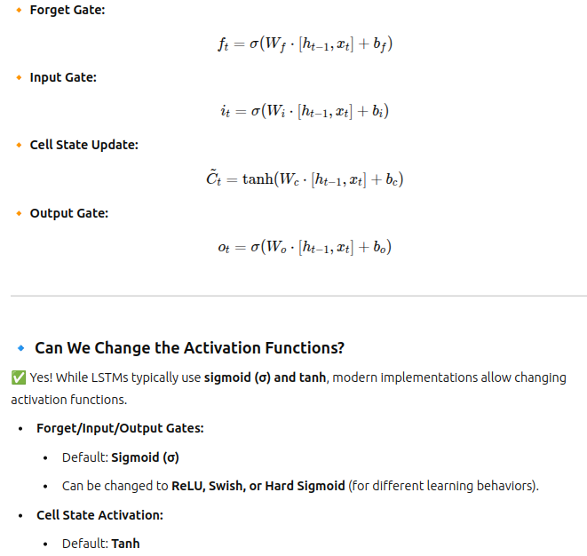
  - 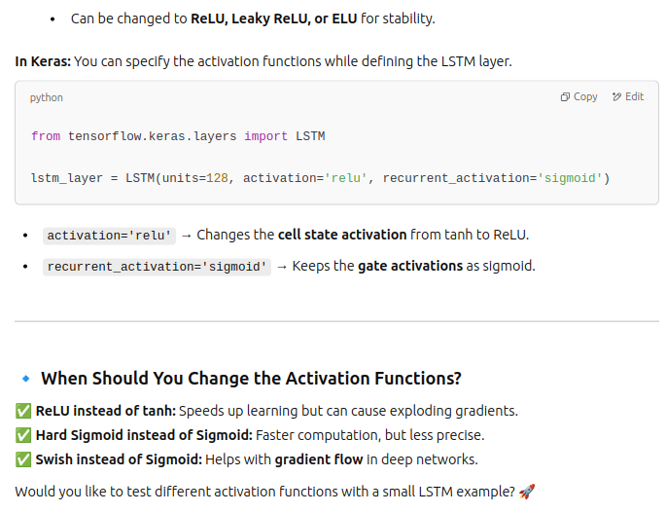

- FORGET GATE
  - 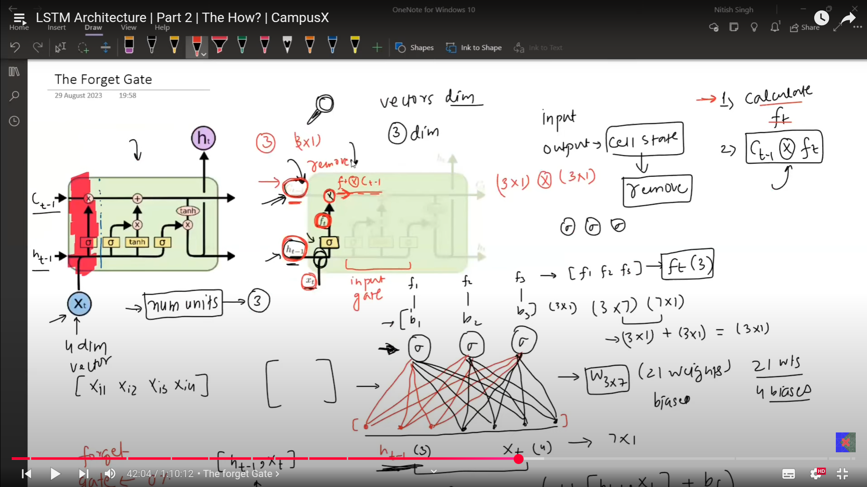
  - The forget gate has 2 inputs first x11, then from the previous hidden state.
  - The shape of weights from the prvious hidden state and number of nuerons must be of the same size.
- Input Gate
  - 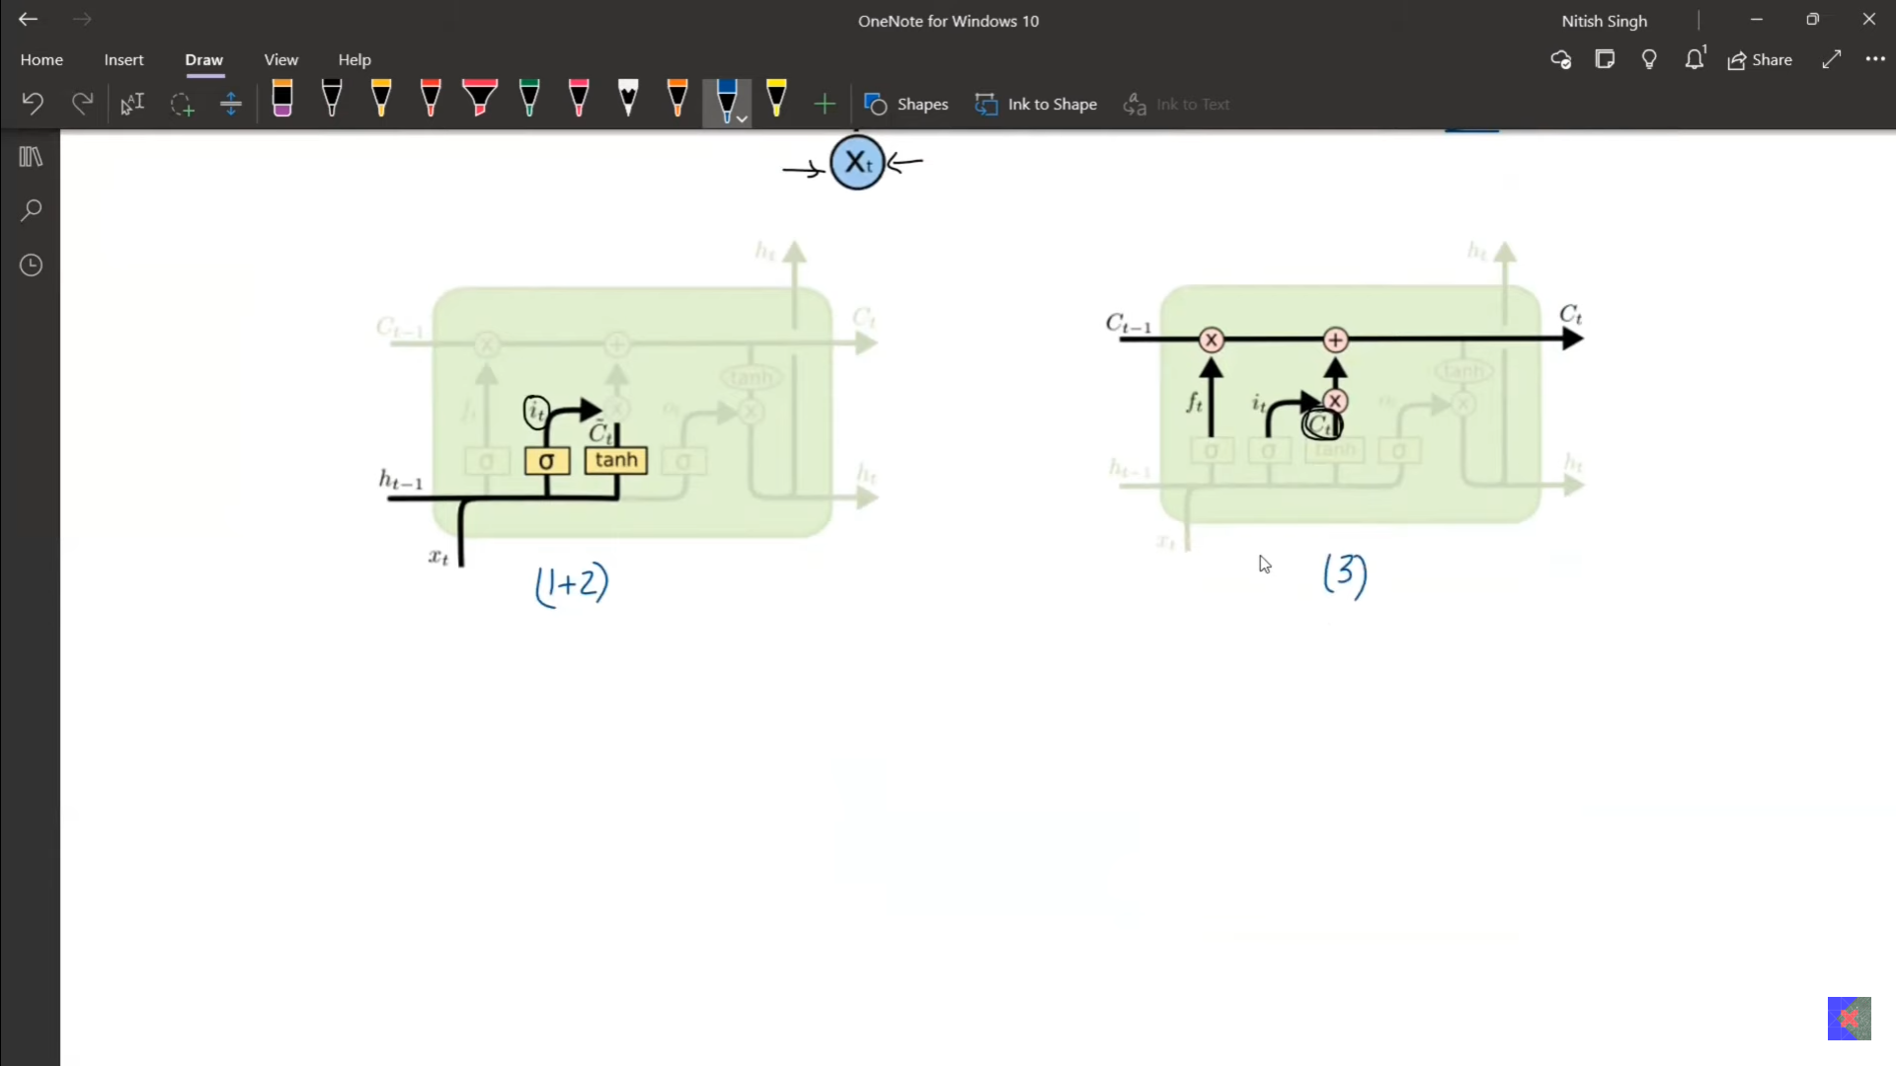
  - 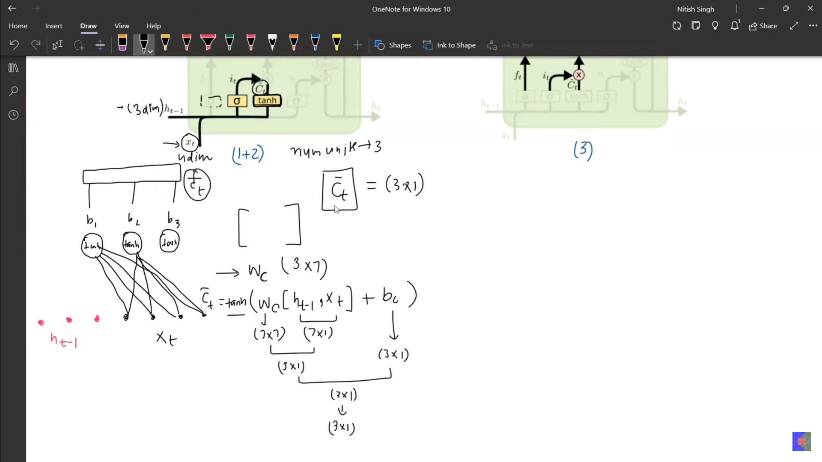
  - 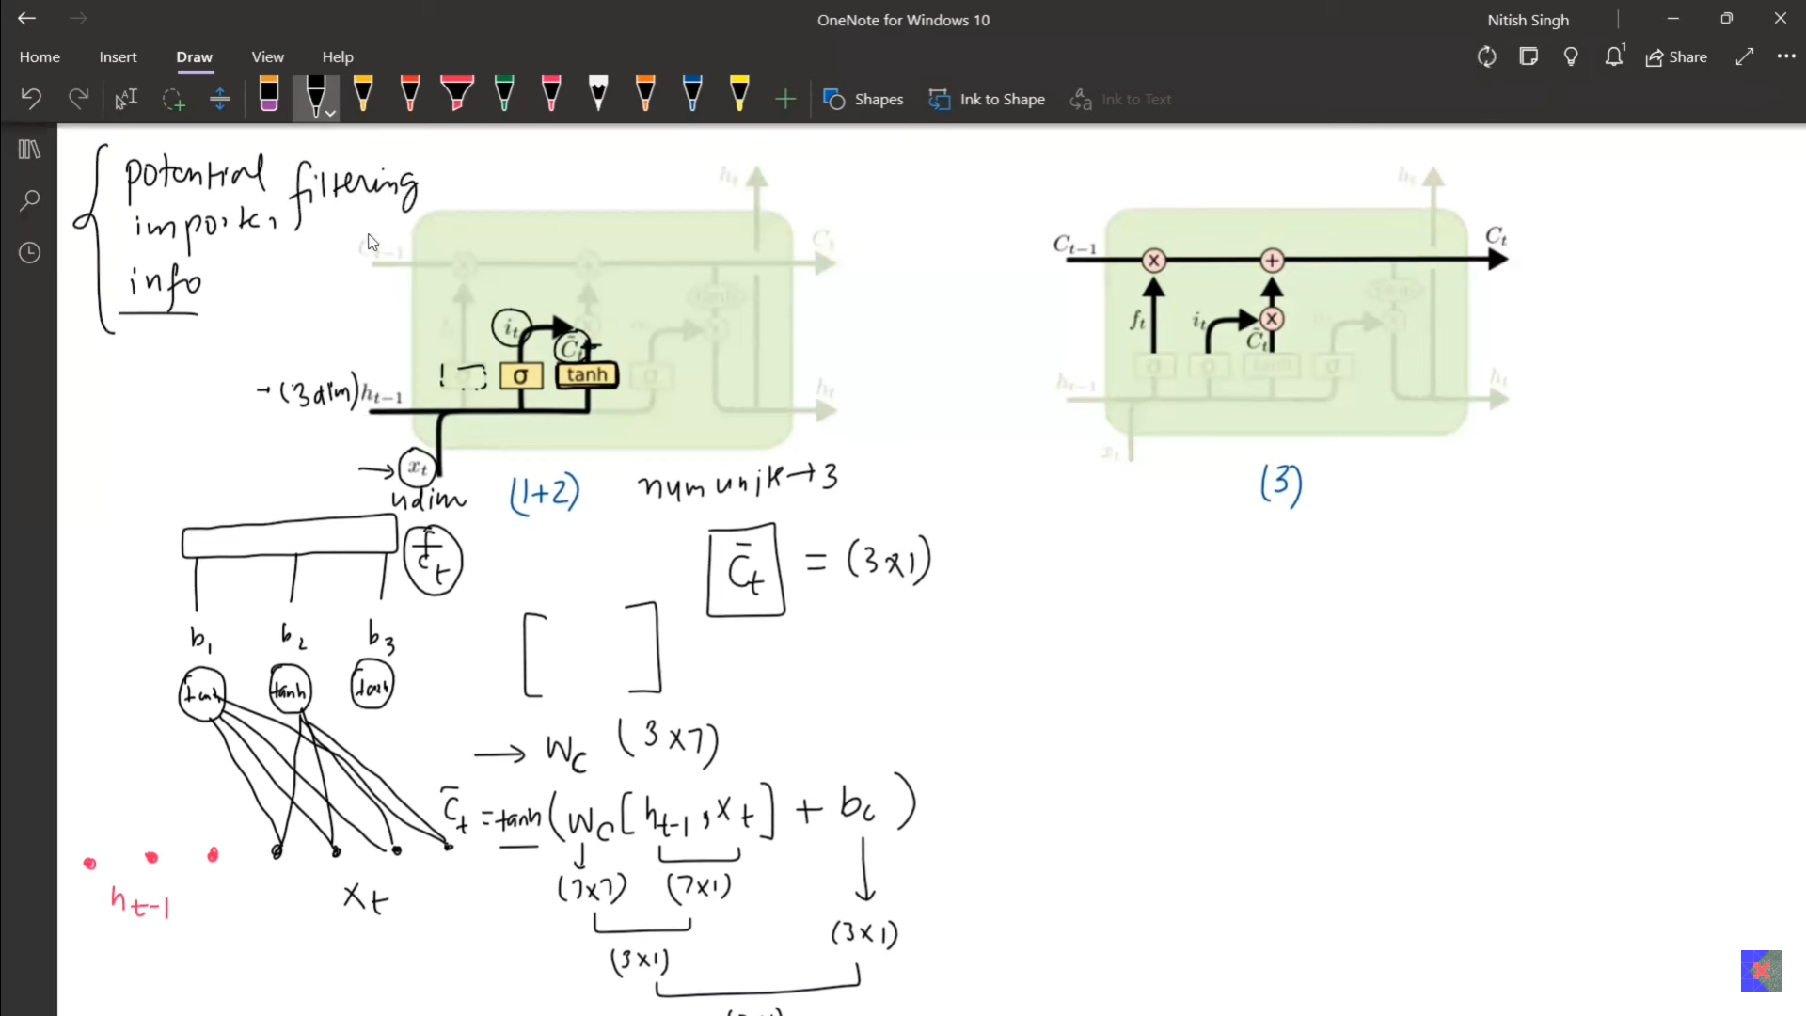
  - 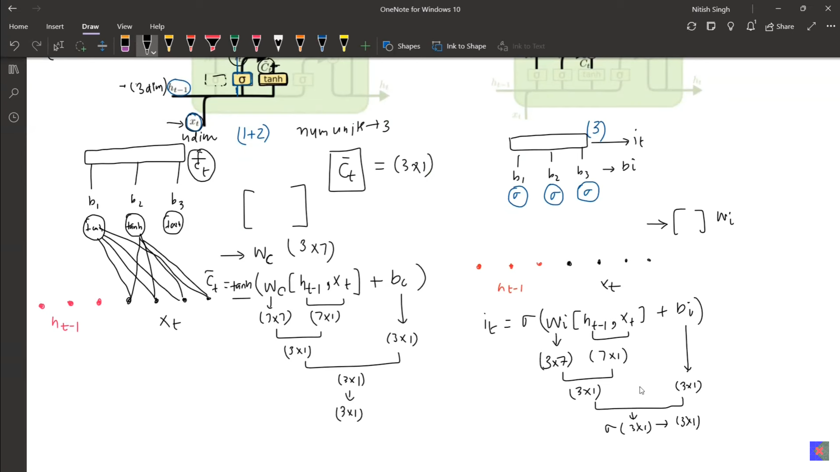
  - 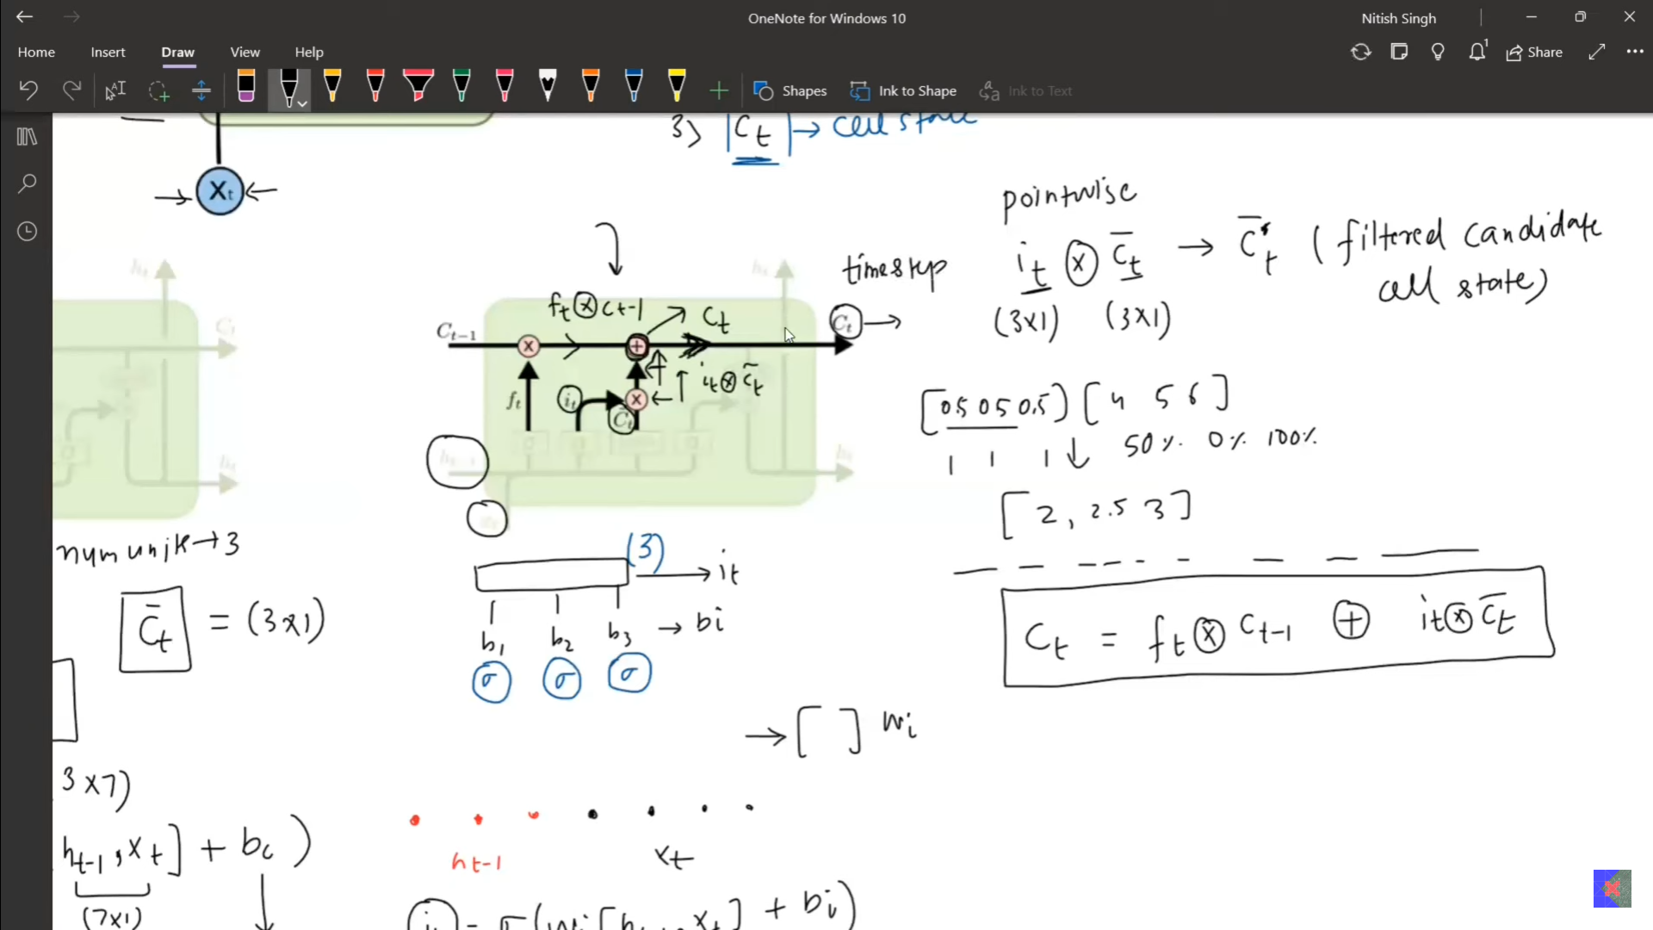
  - The problem with the RNN is the vanishing gradient when we have more number of layers in it. IN RNN there is chances of vanishing.
  - By chaning here it can be removed.
  - 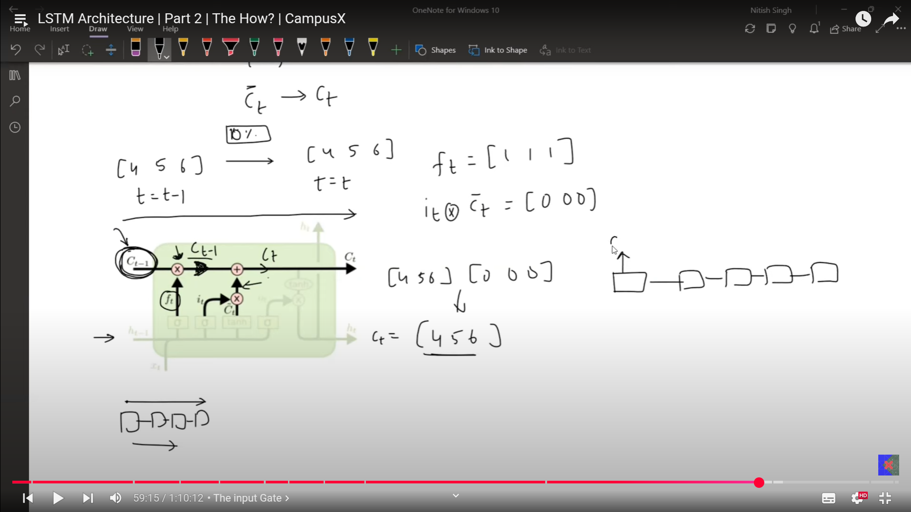
  - if the ft, all of them are 1, then in output from the input gate is 0 all. Then we get the same input even after moving on for many number of layers. This opportunity is not availabe RNN. By defult that will be vanished.
  - Long term state is manitained.
- Output gate:
  - 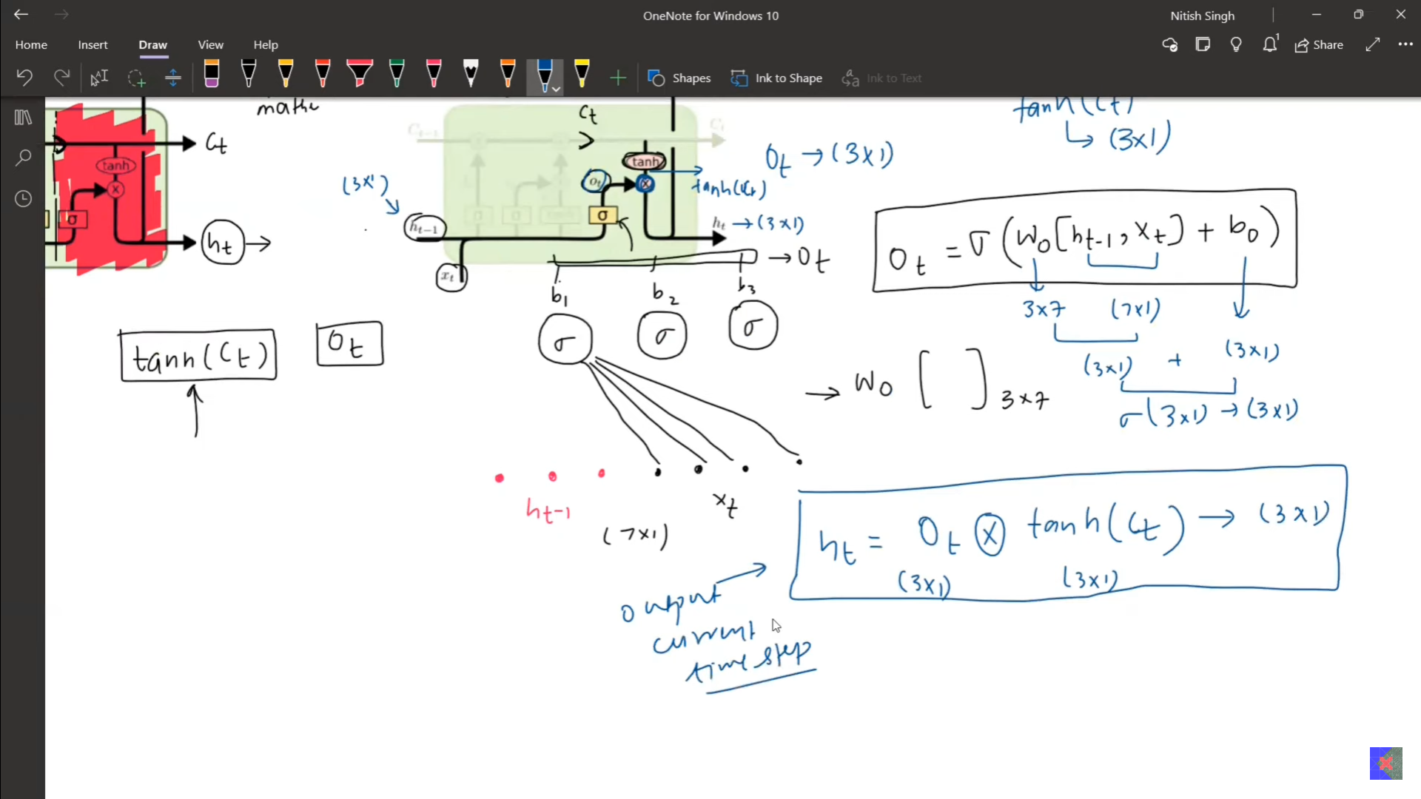
  - 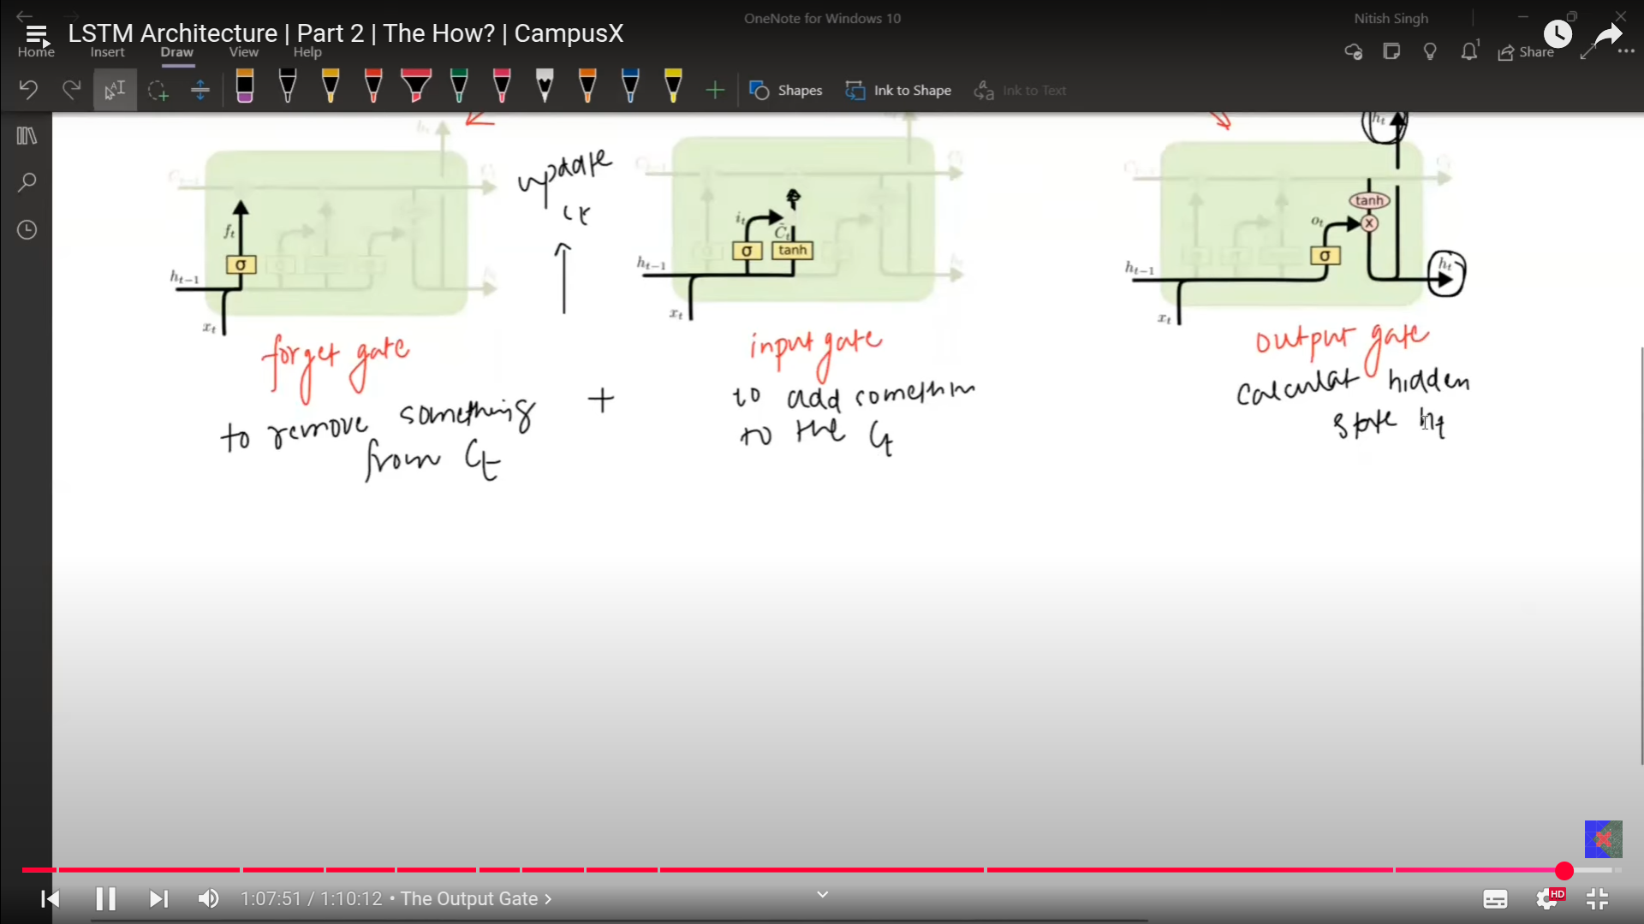
  - 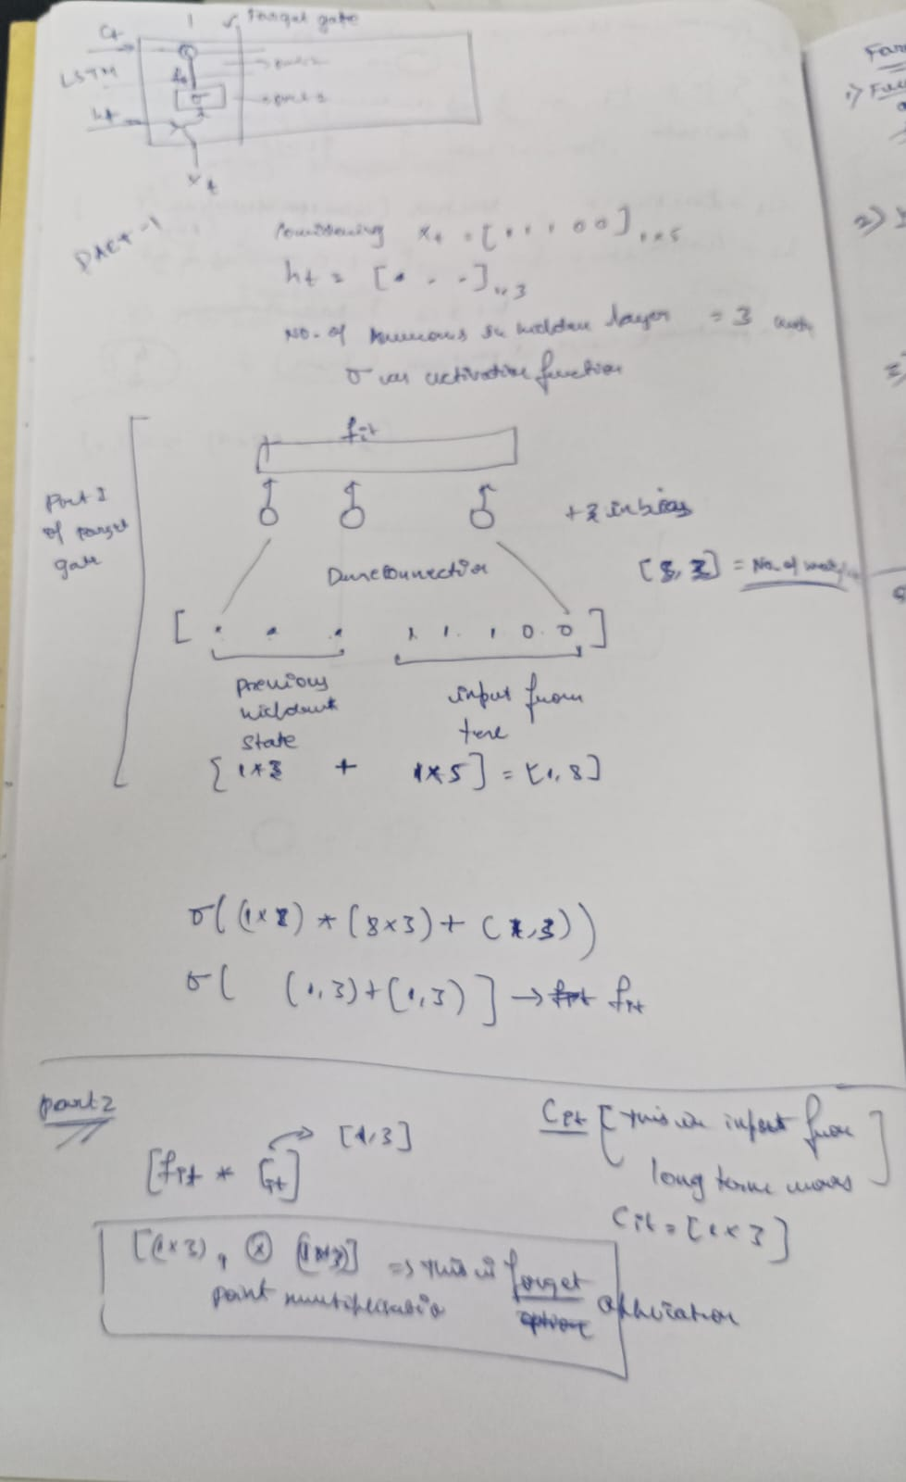
  - 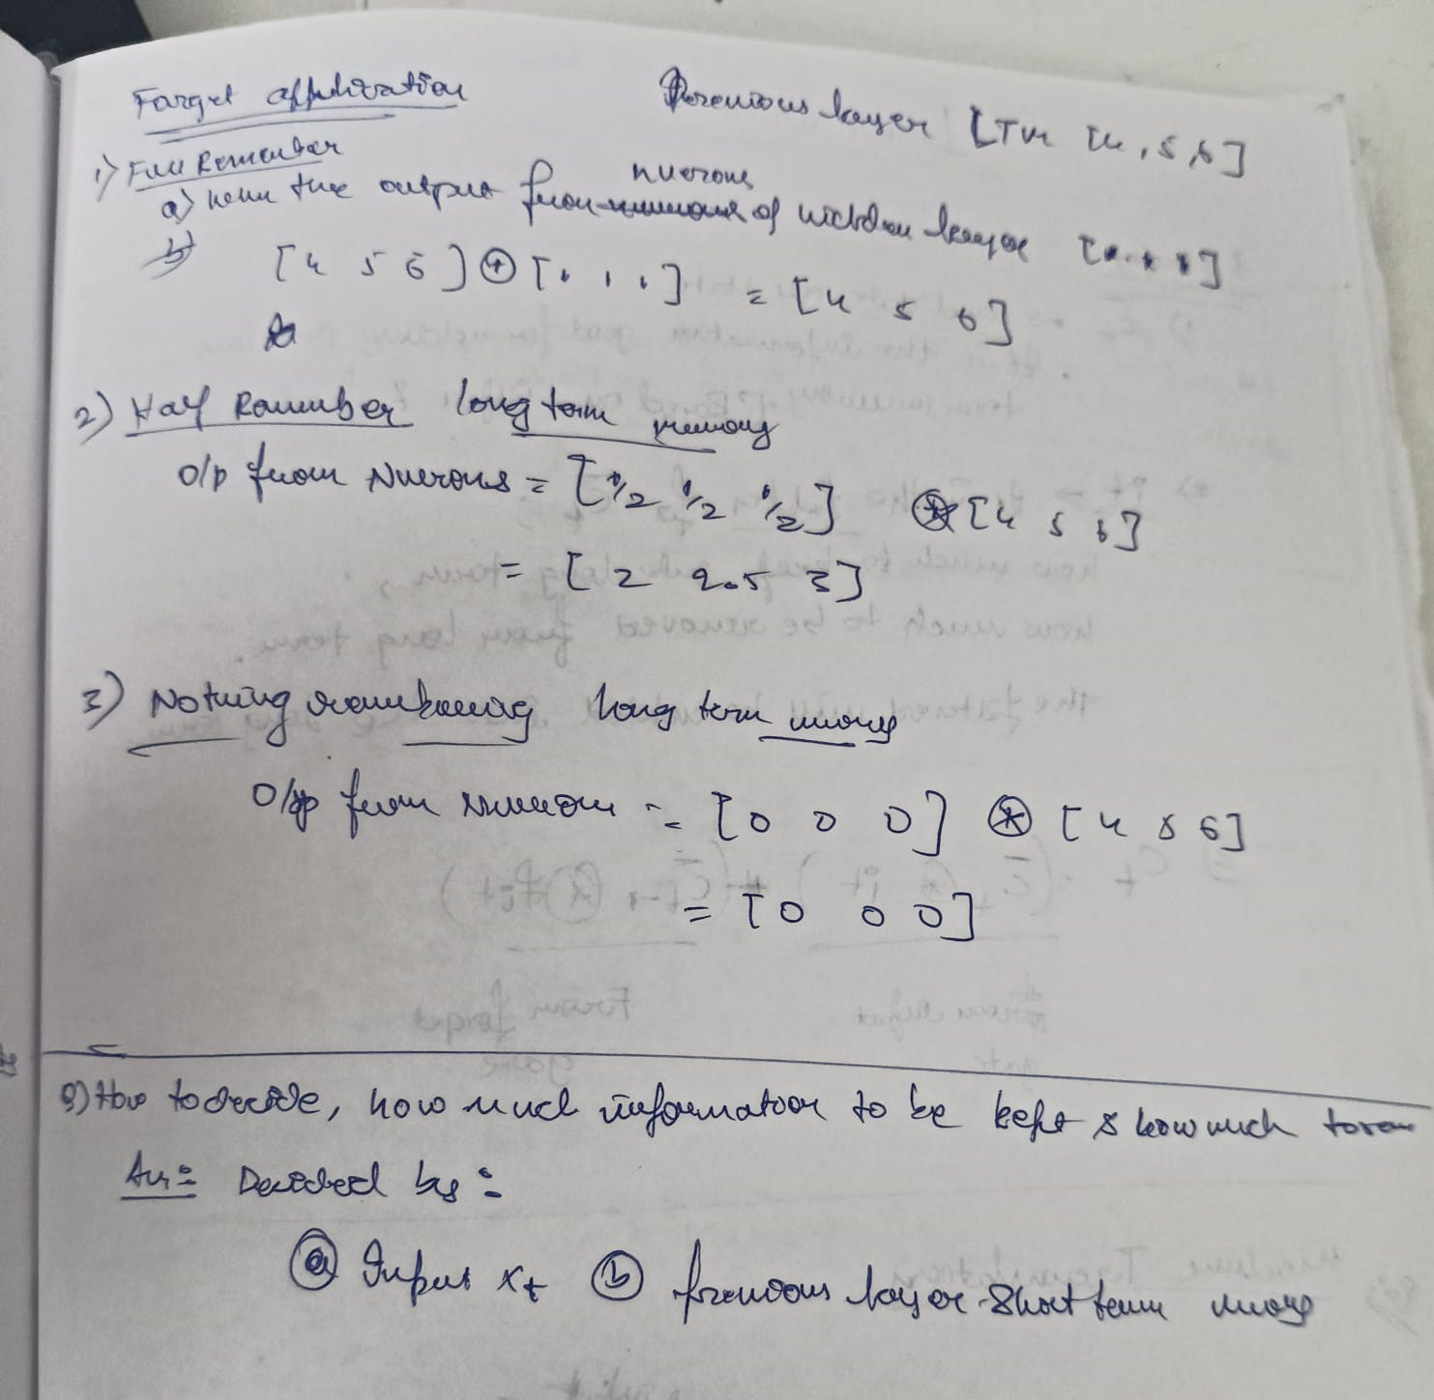
  - 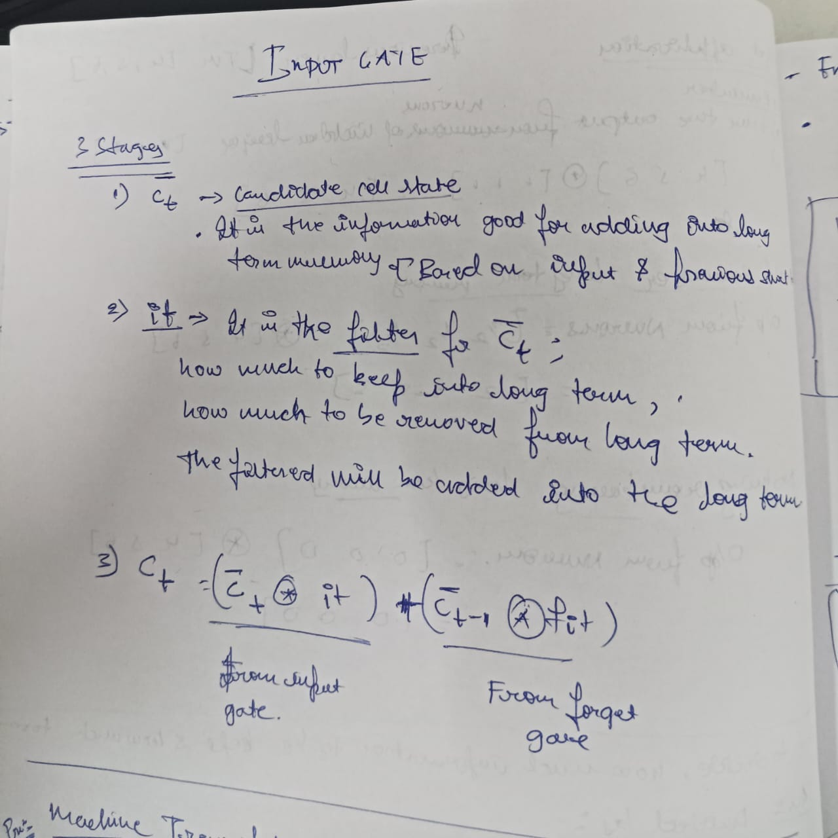

- NEXT WORD PREDICTOR

  - S
- s

